INEQE Independent Safeguarding Audit - model copy for newsletters, pew sheets, websites and social media

Model copy for newsletter or pew sheet

The INEQE Independent Safeguarding Audit – share your views

The Independent Safeguarding organisation INEQE will be auditing safeguarding across the Diocese of Chelmsford in February. It is part of a Church of England wide series of audits to help ensure dioceses and cathedrals are doing everything they can to create environments where people feel safe, valued and respected in our church communities.

Ahead of the Chelmsford Diocese audit they are asking people to take part in a short survey.

The survey is anonymous and confidential, and the results go straight to INEQE. It is also very straightforward to complete. It’s really important that they hear from as many people as possible in our church communities, so please do take a short time to share your views.

There are different versions of the survey for different groups of people. If you belong to more than one group, please fill out a survey for each group you belong to. The surveys for Chelmsford Diocese can be accessed by clicking the button below. They will remain open until 11.30pm on 8 December.

To complete the survey, visit ineqe.com/churchofengland/chelmsford/ or use the QR code below.

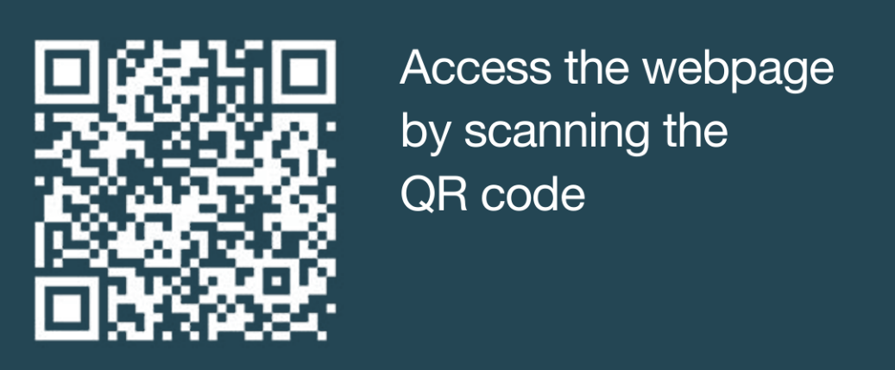

Model website article

The INEQE Independent Safeguarding Audit – share your views

The Independent Safeguarding organisation INEQE will be auditing safeguarding across the Diocese of Chelmsford in February. It is part of a Church of England wide series of audits to help ensure dioceses and cathedrals are doing everything they can to create environments where people feel safe, valued and respected in our church communities.

Ahead of the Chelmsford Diocese audit they are asking people to take part in a short survey click here to take part.

The Bishop of Chelmsford and our Area Bishops of Barking, Bradwell and Colchester have recorded a video encouraging people from church communities to take part in the survey. Their video can be watched below.

Click here to watch the video.

Take part in the survey
There are different versions of the survey for different groups of people. If you belong to more than one group, please fill out a survey for each group you belong to. The surveys for Chelmsford Diocese can be accessed by clicking the button below. They will remain open until 11.30pm on 8 December.

Click here to take part in the survey

Links and embed codes to add to websites:

- Survey: https://ineqe.com/churchofengland/chelmsford/
- YouTube link: https://youtu.be/Wlv0E9Lgsog?si=oDkfFKoR506CEQYG
- YouTube embed code: <iframe width="560" height="315" src="https://www.youtube.com/embed/Wlv0E9Lgsog?si=oDkfFKoR506CEQYG" title="YouTube video player" frameborder="0" allow="accelerometer; autoplay; clipboard-write; encrypted-media; gyroscope; picture-in-picture; web-share" referrerpolicy="strict-origin-when-cross-origin" allowfullscreen></iframe>

Model copy for social media

Post with graphic
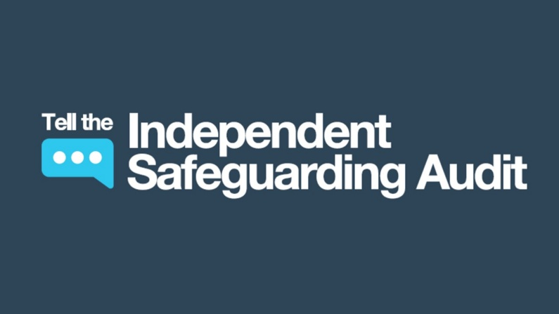
At <Name of church> we’re encouraging everyone in our church community to take part in an important survey ahead of the INEQE independent audit of safeguarding in the Diocese of Chelmsford in February. The survey is open until 8 December. Find out more and take part- https://ineqe.com/churchofengland/chelmsford/

Post with bishops’ video message
Our bishops are encouraging people from churches across Chelmsford Diocese to share their views in an important independent survey about safeguarding.

Watch the video - https://youtu.be/Wlv0E9Lgsog?si=oDkfFKoR506CEQYG
Take part in the survey - https://ineqe.com/churchofengland/chelmsford/

