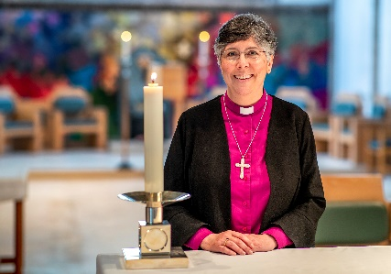
THE DIOCESE: A MESSAGE FROM BISHOP GULI

Covering Essex and East London, Chelmsford is one of the largest, most diverse dioceses in the Church of England. We are home to more than 3 million people representing many socio-economic, ethnic and faith groups and a fantastic variety of cultures and traditions.
We have enormous opportunities for mission and service and considerable challenges to face and resolve as we continue to deal with the local, national and global challenges that have a direct impact on our parish churches, schools, chaplaincies and the communities we serve.
It is within this context and following a period of listening and discernment that started when I became Bishop of Chelmsford in 2021, that we set out a future direction of travel as a Diocese with a focus on travelling well together:
- Our purpose is to love God and to love our neighbour; to worship faithfully and empowered by the Holy Spirit, witness to the love of God revealed in Jesus Christ as we serve the extraordinarily diverse array of local communities in Essex and East London.
- Our approach is to enable and empower parishes and worshipping communities to discern how they are to be God’s people in their own very different local contexts and as part of one diocesan family.
- Underpinning our approach is an invitation to a way of being articulated by shared diocesan values which might shape how we travel together, support each other and provide mutual accountability.
Since I became Bishop of Chelmsford, I have witnessed people’s great warmth and I have seen first-hand, the wonderful things going on in our parishes and schools. Any new priest joining us in the Diocese of Chelmsford does so at a time of challenge, a time of change and most significantly a time of hope for our Church in this most diverse and vibrant of dioceses.
+Guli
Bishop of Chelmsford


Find out more about our Diocesan Direction of Travel and Values:

www.chelmsford.anglican.org/travelling-well-together

