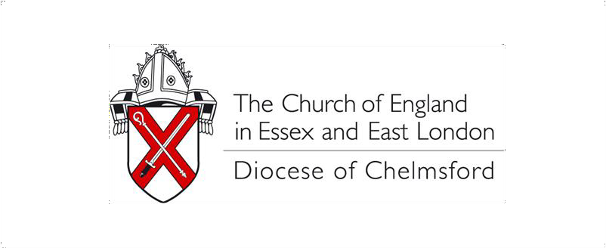.

Social media copy: The Bishop of Chelmsford’s Lent Appeal 2024 #ChelmsdioLentAppeal

This year's Bishop of Chelmsford’s Lent Appeal is raising funds to support the Diocese of Jerusalem’s Healthcare Ministry. The Episcopal Diocese of Jerusalem is home to about 7,000 Anglicans worshipping in 28 congregations across five different countries or territories: Jordan, Palestine, Lebanon, Syria and Israel. The Diocese’s health ministry programme plays a huge role in supporting people in such a vast region, offering health services and social care to those in need regardless of race, religion, or ability to pay.

One of the ways you can support the Bishop of Chelmsford’s Lent Appeal is by sharing the details of the Appeal through your networks.

If you would like to promote the Appeal through your Church or personal social media accounts, this document contains some ideas for the copy you might use.

Posts work really well if they are accompanied by an image or a graphic. Photos and graphics can be downloaded from the resources section of our Lent Appeal webpage www.chelmsford.anglican.org/lent-appeal.

Please try to include the #ChelmsDioLentAppeal so that we can easily track the campaign, measure engagement and re-share posts.

Example posts for X (formally Twitter).

This year’s #ChelmsDioLentAppeal is raising funds to support the Diocese of Jerusalem’s Healthcare Ministry across Jordan, Palestine, Lebanon, Syria and Israel. Find out more and donate here - https://buff.ly/3t5wRuP

We're supporting the Diocese of Jerusalem’s Healthcare Ministry through this year’s #ChelmsDioLentAppeal. The diocese’s healthcare institutions range from retirement homes to therapeutic residential facilities for SEND students and hospitals. Donate here - https://buff.ly/3t5wRuP

Example posts for Facebook & Instagram

This year’s #ChelmsDioLentAppeal is raising funds to support the Diocese of Jerusalem’s Healthcare Ministry across Jordan, Palestine, Lebanon, Syria and Israel. The funds raised through year’s Bishop’s Lent Appeal will help the Diocese continue this invaluable ministry, offering health services and social care to those in need regardless of race, religion, or ability to pay. If you would like to support the Appeal, find out more and make a donation here - https://buff.ly/3t5wRuP.

Join us in supporting the Diocese of Jerusalem’s Healthcare Ministry through this year’s #ChelmsDioLentAppeal. The diocese’s healthcare institutions range from homes for the elderly, to therapeutic residential facilities for special needs students, to clinics, rehabilitation centres and hospitals. If you would like to support the Appeal, find out more and make a donation here - https://buff.ly/3t5wRuP.

