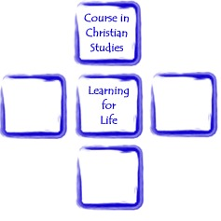

UNIT J: EVANGELISM

Contents and page numbers for Unit J

Session 1: What brings people to faith? Page 3
Session 2: The Kingdom of God? Page 9
Session 3: Then who can be saved? Page 14
Session 4: How can we spread the Gospel? Page 18
Session 5: Far & Wide – How far, how wide? Page 21

Assignment Topics: Page 23

Written 2026 by Revd. Rose Braisby, with grateful thanks to friends and colleagues for their input. Thanks are also due to the Evangelical Alliance and partners (Alpha, HOPE Together, Luis Palau Association and Kingsgate Community Church) for permission to use the information from Talking Jesus Report (2022)

UNIT J: MISSON & EVANGELISM
Session 1: What brings people to faith?
Aim: In this session we begin by thinking about how we came to faith, what drew us towards Christianity and what we first believed. It is assumed that the group when it first came together agreed some kind of ‘group contract’, which presumably included that this was a ‘safe place’ for open discussion; and as it is very likely that group members will hold a wide range of views, that as a group we will respect each other and what we believe. We will continue to keep discussions confidential.
 Opening worship suggestion: sing along to the video https://www.youtube.com/watch?v=-pDO2hLLWLw “For I’m building a people of power”
Tutor Explanation
Everyone has some beliefs, whether or not they call it “a faith”. In this Unit we will discuss what we believe, how important it is (or maybe not) for others to share the same or similar beliefs, within and beyond the church. Tutors will encourage students to learn from each other’s beliefs and experience of our faith.
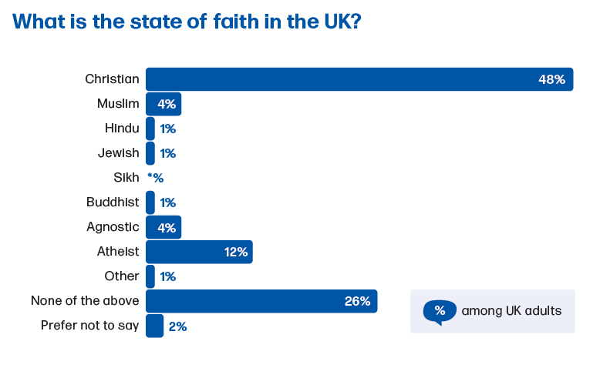
Christian: 48%, down from 58% in 2015.
Overall the 48% varies with age: 63% of age 65+, 29% aged 18-24

None: 26%, up from 11% in 2015.
27% of age 18-24

Atheist: 12%; 20% of those aged 18-24

Muslim: 4% of population (12% of Londoners); 14% of the 4% are aged 18-24.
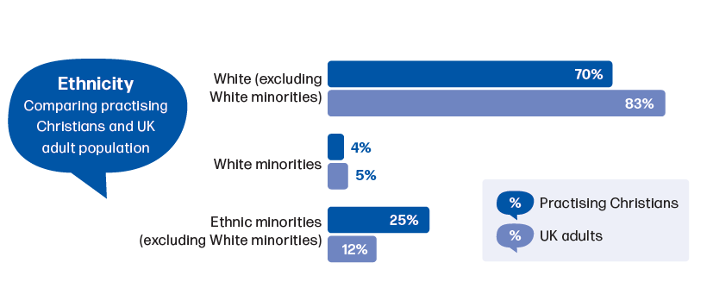
…ethnic minority groups are more strongly represented as practising Christians and have a higher reach than the white practising Christians amongst their percentage of the population.

 Tutor led Group work in small groups, then debrief.
- Read the story of the Good Samaritan (Luke 10:25-37)
- Can you summarise what God requires us to do and be?
- How does this differ from the “Golden Rule” which is common to many faiths/societies?
Tutor led Group work in small groups, then debrief.
- Read Luke 10:1-20, or John 3:3-9, or Matthew 28:16-20
What did Jesus do to bring people to faith?

Tutor led discussion. What brought you to your faith?
Coffee Break
Tutor Input

We have some fairly recent evidence of what brings people to Christian faith: Talking Jesus Report 2022 - State of faith in the UK.*
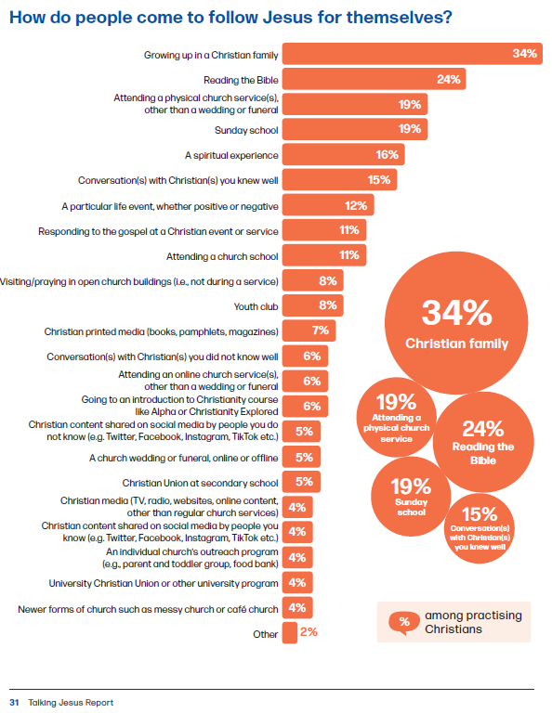
Tutor led discussion.
- Are there any surprises in these statistics?
- Would you think other faiths would show similar results?
- What impact do the “Baptisms, Weddings, Funerals” ministries apparently have on people coming to faith, according to these statistics?
- Are these services really about “faith”, or just “folk religion”?
- Does “faith” change over our lifetimes?

Tutor led Group work in small groups, then debrief.
- Groups to look at the stats for Baptisms or Marriages or Funerals, then compare findings and comments. Remember Group members may have personal experience of all these and there may be sensitivities. Be kind to one another!

Number of Church of England baptism and thanksgiving services that took place from 2009 to 2023 (in 1,000s)
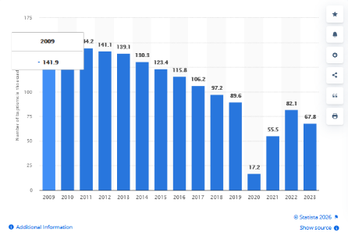

Source: https://www.statista.com/statistics/369110/church-of-england-timeline-baptisms/#:~:text=n%202023%2C%20there%20were%20approximately%2067800%20baptism,of%20England%2C%20compared%20with%2082100%20in%202022.
Live births in England & Wales in 2023: 591,023
Adult baptisms 2023: 7800 2024: 8700
Teen baptisms 2023: 2100 2024: 2400
So: Child baptisms 2023 approx 58K
Source: https://www.churchofengland.org/media/press-releases/attendance-church-england-churches-rises-fourth-year-row

MARRIAGES
“Church Times” 20 November 2025
THE Church of England conducted fewer weddings than ever in 2023, as the number of people in England and Wales getting married in religious ceremonies slumped to a new low.
In 2023, 23,004 marriages were recorded by the Church of England and Church in Wales, according to data released by the Office of National Statistics (ONS) on Tuesday. It is the lowest number since the 1830s, except for 2020, when churches were closed during the pandemic, and wedding numbers across the country were fewer than half the rolling average.
In total, 216,901 weddings of opposite-sex couples took place in 2023, a drop from 239,097 the previous year. The majority (184,428) were civil ceremonies.
There were 32,473 religious weddings, of which 70 per cent were held in Anglican churches. This is a slight percentage drop from 2022, when, out of 41,824 religious weddings, the Church of England or Church in Wales officiated 30,784.
The largest single denomination to conduct opposite-sex religious weddings in 2023, after the Church in England, was the Roman Catholic Church, which conducted 3303. Other Christian denominations conducted a further 3629 marriages, and there were 2537 non-Christian religious ceremonies.
There were also 7501 same-sex marriages in England and Wales in 2023, of which 96 were religious ceremonies. Neither the Church of England or Church in Wales currently permits same-sex weddings.
The Methodist and United Reformed churches both conduct same-sex weddings in England and Wales.
(ons.gov.uk says Saturday 2 September 2023 was the year’s most popular date for weddings: 287 on that day)

DEATHS & FUNERALS
Number of deaths registered in 2024 There were 568,613 deaths registered in England and Wales in 2024, a decrease of 2.2% compared with 2023 (581,363 deaths). Source: ons.gov.uk
Article from Theos, 20 April 2023
How we mark death is changing. That’s one of the headlines from our recent Theos report Ashes to Ashes on attitudes towards dying, death, and the afterlife in the UK – and if how we understand death says anything at all about what we think of life, the shift should be understood as a key indicator of important social changes under the bonnet of British society and culture.
Most obviously, traditional funeral services are in decline. The classic image of a church funeral is increasingly unrepresentative of British funeral practices on the ground. The latest data suggests that the Church of England conducts funerals for 23% of deaths, but even this share is decreasing. Statisticians report a sharp decline in Christian funerals from 1999 to 2019; the Church of England observed a 50% decline over the same period and other Christian denominations echo a similar pattern… According to research by the Co–op in 2019, only 1 in 10 Brits now want a religious funeral of any kind.
Source: https://www.theosthinktank.co.uk/comment/2023/04/20/the-death-of-traditional-funerals
A typical example of an advertisement for Direct Cremation (this is from www.coop.co.uk)
A direct cremation with Co-op Funeralcare is a low-cost simple cremation with no service, mourners or ceremony and no visitors to the funeral home.
A pure and simple, unattended cremation with no funeral service that people can go to.
So you can say goodbye in your own time, in your own way.
You won’t pay more than £1,445 – no hidden costs.
Arrange online, on the phone or in a local funeral home.
We never charge for home collections, unlike some other providers.

Tutor Input
The “Statistics for Mission” figures for each parish/benefice are tallied every year. Your Churchwardens will probably be able to let you know the figures of Baptisms, Marriages and Funerals for recent year(s) if you ask.
For next week: See if you can find out how the local statistics have changed in recent years, and think why that has happened?

Closing worship

UNIT J: MISSON & EVANGELISM
Session 2: The Kingdom of God?
Aim: In this session we look at the sort of evangelism which may be going on in the group’s home parishes.
Opening worship suggestion: sing along to the video https://www.youtube.com/watch?v=mOrkdW5NAM0 “The Kingdom of God is justice and joy”
Tutor Input
- Evangelism – the preaching of the ‘Gospel’ involving a set of beliefs that draw people into faith in Jesus Christ.
- Mission - includes evangelism but is broader in its aim and includes an understanding of the culture in which mission is focussed and other activities that might draw someone to (Christian) faith.
- The first successful Christian evangelist we know about isn’t one of the Twelve: it’s a woman from Sychar, in Samaria. Read: John 4:1-30, 39-42
So “many Samaritans” came to belief through her words.
Remember from J1: the “Talking Jesus Report”
So this was one who would be within the 6% slot – she didn’t previously know Jesus at all (but it was Jesus talking to her!) So even Jesus didn’t only go for certainty – and we know that even some of the Twelve doubted, even after the Resurrection (Matthew 27:17).
- Some people criticise the CofE’s attitude to evangelism: Martyn Percy says it has a formulaic approach, obsessed with numerical growth. Is that fair?
- Week by week, people evangelise through services in the local churches: the Sunday services, and the “Occasional Offices”, the Baptisms/Christenings/Thanksgivings, the Weddings, the Funerals.
Debrief homework findings – possible areas to cover
- What did they find out about these services in their own parishes/benefices;
- What effect do these services have on the usual congregation?
- What effect do these services have on those others who attend?
- Do people come to faith through the services/through the preparation courses involved?
- Is there any interaction between the families and lay people in the church?
- Are group members involved in these services or the preparation courses involved?
- What other “civic and sentimental*” Christian services do their churches hold?
(*the term used by Stuart Murray in “Post Christendom”, p199)
- Is it likely that the expectations of the Church will change, given the changing politics of Europe (see Spectator article 30 August 2025, about Denmark, below)?

Tutor Input
- Are these hatching/matching/despatching services what Jesus told us to do?
Baptism: Matt 27:19 (The baptismal words are also given in The Didache, the teaching instructions for early Christians, which may date back to as early as 50 A.D., more likely 70-80 A.D., but may well pre-date the Gospels.)
Mark 16:16 (perhaps a later addition)
John 3:5
Performing weddings: (Jesus helped with the party after the wedding at Cana!)
Burying the dead: (One of the Ten Commandments in Exodus 20:-10, Deut 5:1-23, tells us to honour our father and mother; St Paul reminds the Ephesians of it in Eph 6:2.)
- Why then does CofE spend so much time on them?

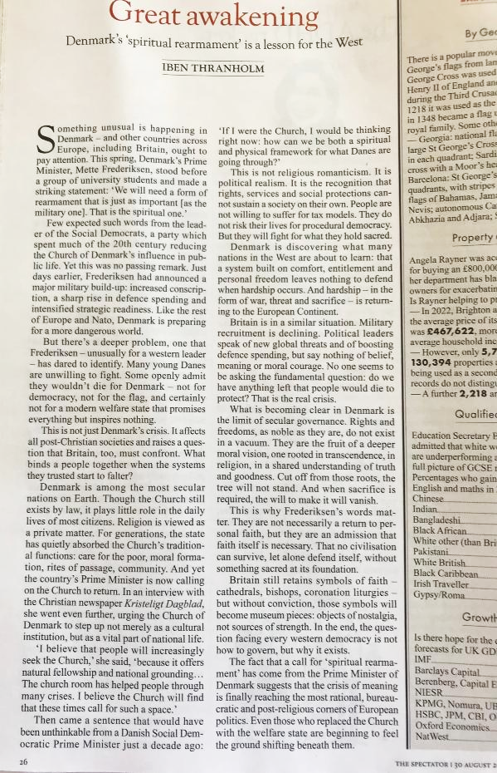
Tutor Input
- Mark records (Mk 1:15) that Jesus told people to “repent and believe”.
- “Repent” The Bible has John the Baptist saying this at Matt 3:2 and Jesus saying it at Matt 4:17. It’s likely that people heard this in corporate, covenantal terms in accordance with the Old Testament demands on the People of Israel, rather than as a call to individual, personal repentance.
- “Repent” means to feel and show that you are sorry for something bad or wrong that you have done (Oxford English Dictionary).
- The Coverdale Bible (1535) used the word “amend”, which means to alter, to change, to improve something.
- In Hebrew, the word is “Teshuva” (pronounced “tchoovah”), which implies much more of a continuing decision to turn back, a process of which regret is only one stage. It’s the expression used in Joel 2:12.
- The Greek New Testament uses “metanoia”, which means a complete change of mind. What Jesus means is that we must abandon our old attitudes and behaviours, yes, feel sorry and apologise, but having wiped the slate clean, must start afresh and continue forward with the right attitudes.
Tutor led Group work in small groups, then debrief.
- The Kingdom of God is announced as being near, by John the Baptist (Mark 1:15); Jesus tells us to strive for it (Matt 6:33); he says that it’s among us (Luke 17:2,21); yet he says that it’s not of this world (John 18:36). What can we know about it?
In groups, consider what these parts of Scripture tell us:
- Matt 7:12; Luke 6:31;
- Matt 5:44; Luke 6:27-8;
- Luke 15:3-7; Matt 18:10-14;
- Matt 25:31-42; Luke 15:8-10;
Coffee Break
Tutor Input
- One of the reasons for the division of the early Church from Judaism, was that whereas Judaism demanded orthopraxy – right behaviour, following the Laws of Torah – the new Church demanded orthodoxy – right belief (very necessary in the pluralist Gentile Church). In particular, the Church demanded right belief in the divinity, the life, the work, the death, the resurrection and ascension of Jesus; this was intolerable when Judaism was under direct attack from Rome (cf the fall of the Temple in 70 CE). The exact requirements of orthodox Christian belief were hammered out over several hundred years, and crystallised in the Nicene Creed of 325 and 381,

- There have been massive outbreaks of evangelistic fervour, even in the CofE – the C18th – when preaching moved from the churches to the people (Wesleys, Whitfield etc.) and there was “The Great Awakening”. There were multiple examples in the United States. One consequence was the schism in the CofE which led to the formation of Methodism.

Tutor led Group work in small groups, then debrief.

- Churches typically try to live out their faith through worship and helping/loving neighbours. Examples?

- The education system and the Welfare State have been built since c.1870. What effect has there been on the Church?

- How does the role of the ministry (lay/clerical) vary across the CofE in the light of these changes?
Tutor Input – Sector Ministry
If our work is in Sector ministry: how we both articulate and express our faith will change significantly if working in Prison or Hospital Chaplaincy. NHS Hospital Chaplaincy offers support to everyone in Hospital, with or without a faith. Chaplains and volunteers are instructed to never ‘proselytise’ and to use bed-side encounters to discover the patient’s own concerns worries and beliefs and to help the patient from the patients’ own world view (be it of Christian, non-Christian or of no faith) to find strength and perhaps hope.
A chaplain to the Police, Ambulance or Fire Brigade, will use their faith as their founding-stone as they seek to be a confidant or support to those who face trauma daily in their work, but will need to be available and open to support those of different faith and none.
What are the strengths and challenges of this sort of ministry?
Do you know of any other types of Sector Ministry? (e.g. Airport, Police, Fire Brigade, Shops…)

For next week: see if you can find out about any local Sector Ministers, and if possible talk to them about their work.
Closing worship

UNIT J: MISSON & EVANGELISM
Session 3: Then who can be saved?
Aim: In this session we will look at some of the differing approaches to salvation within the CofE.
Opening worship suggestion: sing along to the video https://www.youtube.com/watch?v=FFxZeY2D5tc “Seek ye first the Kingdom of God”
Debrief homework findings – what did they discover about Sector Ministry?
Tutor Input – Universalism and Predestination
Can we be saved?
Can people not like us be saved?
One of the major arguments of the Reformation was (and is) the extent to which God controls or micro-manages the world.
Followers of Calvin believe that God determines everything, including our choices, and that of God’s sovereign will (so nothing to do with individual humans), God elected before time that certain people should be saved, and others not. This is called “Unconditional Election” or “Predestination”.
The Roman Catholic Church is not Calvinist. Various other churches do adhere to Calvinist beliefs – that includes the URC (formed from Congregationalist and Presbyterian traditions), the Reformed Baptist Churches, the Free Presbyterian Church of Scotland, and the Church of Scotland (the “Kirk”).
Some Christians believe that all humans will eventually be saved – this is known as “Universalism”.
The Church of England does not have an official view on Universalism/Election: it includes people of both views.

Tutor led Group work in small groups, then debrief.
Read: (a) Matthew 19:16-30; John 6:65 Luke 8:4-15
(b) John 14:1-6 1John 2:2 Mark 4:1-20
- What do group members think the Bible readings above tell them?
- Does the group know if their own parishes/benefice have a view on this point?
- is it “worth” trying to save everybody if only some are pre-destined to be saved?
Tutor Input – recap on basic theories of Atonement
BASIC THEORIES OF ATONEMENT – when did it happen?
Jesus’ Birth – Incarnational theory.
Schleiermacher – God became human so we can become like him
Irenaeus – Christus Victor – Jesus’ struggle against evil is part of eternal plan, comes into action with incarnation
Jesus’ Life & Teachings
Abelard – Moral Exemplar – Jesus gives so powerful an example of love and obedience, we have to follow
Jones & Moltmann – Solidarity – Jesus always stood with the poor and marginalised, so his death was the natural outcome of that. Our identification with his suffering leads us to identify with and stand with the marginalised
Wesley? – Healing Servant – sin is a disease that Jesus the Great Physician heals.
Jesus’ Death on the Cross
Augustine/Anselm – Penalty/Satisfaction/Substitution – God’s honour damaged by human sin, someone has to pay the penalty and Jesus does;
or, Jesus substituting for humans on the cross.
Girard – Last Scapegoat – societies need a victim to act as a release valve for violence. Jesus’ death demonstrates the wickedness of this fact.
Jesus’ Resurrection and Triumph Over Death
Origen – Jesus’ death is the ransom paid to Satan (or “Powers” – Wink/Aulen); but Satan no longer has power when Jesus rises, so is tricked out of his ransom.

Tutor led Group work in small groups, then debrief.
- What view of Atonement does your Church generally take, do you think?
- Is that the view you take?
- Has your view, or your Church’s view, of Atonement changed over the years?

Coffee Break

Tutor led Group discussion
- What practical Christian activities take place in some parishes that they know about?
- How do they differ from “Social Services”-type activities?
- Are they specifically “evangelistic” in their approach, as far as they can see?
- If the parish doesn’t do “Social Services”-type activities, what are the risks/consequences for the parish?

Tutor Input – Last week we noted from The Talking Jesus Report:
Tutor led Group work in small groups, then debrief.
- See the statistics on the next page and discuss them.
- How confident do we feel to have these discussions?
- Is it a matter of introversion/extraversion, or something else?
- What qualms or questions would it be helpful to discuss (we can continue this discussion next week)

For next week:
- Think more about any qualms or questions it would help you to discuss in group. Tell the tutor so they can think what might help!
- Is there a lay person in your Church who seems to be good at talking to people about faith? How do they start conversations about faith?

Closing worship

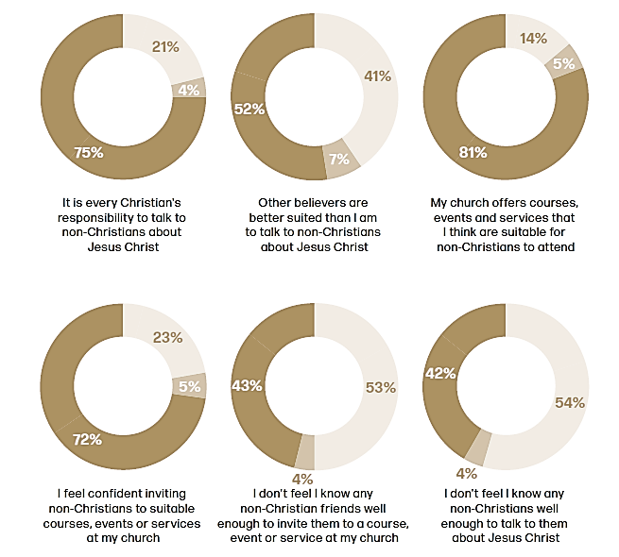
p.22 of The Talking Jesus Report
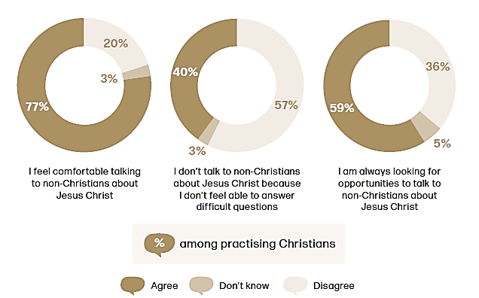
UNIT J: MISSON & EVANGELISM
Session 4: How can we spread the Gospel?
Aim: In this session we look at practical methods of evangelism.
Opening worship suggestion: sing along to the video “Onward Christian Soldiers “ https://www.youtube.com/watch?v=LgybEBy3rlM
Tutor Input
- Processions were banned during the Reformation – do they take place now?
Debrief homework findings
- Is there a lay person in your Church who seems to be good at talking to people about faith? How do they start conversations about faith?
- How confident do we feel to have these discussions?
- Is it a matter of introversion/extraversion, or something else?
- What qualms or questions would it be helpful to discuss
Tutor led Group work in small groups, then debrief.
- What other public Christian evangelism have the group members seen?
(e.g. door-to-door evangelism; “Billy Graham”-type events; Processions of Witness; public Ashing…)
- What evangelistic courses are group members aware of?
- How effective do they think these efforts are?

Tutor led Group discussion
In the book “Evangelism – which way now?” Mark Ireland suggests that Britain has moved from being an evangelism field to a mission field, and demonstrates the difference with a Powerpoint slide by George Lings: but what difference would that make in practice?
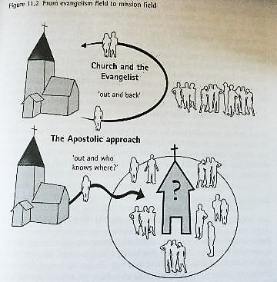
Coffee Break
Tutor led Group discussion
- Does the group know of any supplies or visual aids which might be useful in practical evangelism? (Some examples below)
- Are they teaching gimmicks or of real use?


- What are the dangers if any?

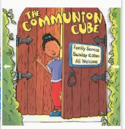


Table Talk For Wellbeing, For Friends, For 12-14s (and there are others); Grave Talk
The Jesus Deck
Cubes: unpacking the Communion; Baptism; The Lord’s Prayer; Evangelism (EvangeCube)

For next week:
p.22 of The Talking Jesus Report
- Find out if any such visual aids are used in your parish, and with what outcomes
- Find out what special occasion services occur in your parish which are intended to involve people who are outside, or on the borders of, your usual congregation.

Closing worship

UNIT J: MISSON & EVANGELISM
Session 5: Far & Wide – how far, how wide?
Aim: In this session we look at pastoral and attractional services, and wrap up the Unit.
Opening worship suggestion: sing along to the video
“We have a gospel to proclaim” https://www.youtube.com/watch?v=B2FX0-kS7wA

Tutor led Group work in small groups, to debrief homework
In “Liturgy on the Edge”, p.xxi,
“We would love it if people who had never or seldom been churchgoers flocked to our Sunday 10 a.m. Eucharist and embraced all its peculiarities from their very first encounter; but in practice our central act of worship proves very attractive to people who already have some or great familiarity with conventional Church of England liturgy, and find with us a better or more conducive version of what they already know. So we must find other ways for people to discover, explore, gain confidence in and make their own the glories and joys and consolations of Christian worship…”
So how do we do that?
- Are any particular visual aids to evangelism used in your parish?
- What special services are held?
- Do they attract different people?
- What about children in church?
Tutor led Group discussion
Some circumstances make it particularly difficult for some adherents of other faiths to convert to Christianity. Our faith requires us to love our neighbour, so interfaith evangelism may require discretion!
As members of the Church of England we are not freelance operators: when we act on the Church’s behalf, we are under authority (whose?)
Read Luke 24:44-end, noting that Jesus is not authorising one single disciple, but the gathered disciples (“...you are witnesses”). This continues his approach from Luke 10:1-23 when he sends them out in pairs.

Tutor led Group work
- Deal with any remaining concerns about joining in evangelism.
- Request feedback on the Unit.
- Note Assignment topics and arrange date for submission.
- Check restart day in the Autumn for Unit K (Pastoral Care).
Coffee Break

Closing worship – perhaps an End of Term service

Assignments

a) Write a reflection (1500 words) on your experience of doing Evangelism. How did it make you feel? What would you change? Were there any results from what happened?

b) “My Life Journey”. In whichever way you would like, using written words, spoken words, pictures, song or any other creative way, tell your faith journey. Don’t forget to include the whole of your journey, including childhood experiences of faith. (1500 words or equivalent maximum)

c) Prepare an outline plan of a suite of 5 services on a particular theme which you hope will appeal to people outside the Church, and would also be supported by Church members. Show the components (including music/songs/hymns if appropriate) and why you have chosen them. (This work should be original and not culled wholesale from existing resources).

d) Write an essay (1500 words) on several methods of bringing people to faith, giving your assessment of how they might work, the reasoning involved, and any experience you have of using them.

Talking Jesus Report, https://talkingjesus.org/research p5, P7
MURRAY, Stuart, Post-Christendom, Milton Keynes, Paternoster, 2004
O’LOUGHLIN, Thomas, The Didache, London, SPCK, 2010
WELLS, Samuel, (editor) Liturgy on the Edge, Norwich: Canterbury Press, 2018

