Application Pack for Team Rector - Billericay and Little Burstead Team Ministry

The Billericay Team seeks and will warmly welcome a Team Rector who can lead us through change with wisdom and grace, helping us grow in faith and unity and equipping us to become a confident and outward-looking parish ready to share the good news.

Purpose of the Role – What we hope for in this season
For an initial 2–3 year season, the Team Rector will be appointed to lead significant spiritual, cultural and structural renewal across the parish of Billericay. The role is explicitly focused on rebuilding trust and strengthening unity so that the parish can move forward together with hope and confidence.
During this season, the Team Rector will lead the development of a shared, parish-wide vision and establish a healthier, more sustainable team-based model of ministry and governance. Following this period of change leadership, the Team Rector will guide the parish into an agreed long-term pattern of mission, ministry and oversight.

Context
The parish of Billericay comprises several congregations with distinct traditions, strengths and histories. Relationships between individuals and churches are often stronger and warmer than is currently reflected in the institutional and governance structures, which have sometimes struggled to hold diversity well or to support collaboration and trust.
Recent conversations across the parish have named challenges including:
- A history of disunity, distrust and unresolved conflict
- An inward focus in places, alongside growing concern for those not currently engaged with church
- Unclear leadership and communication pathways
- Pressured capacity amid ageing demographics
Alongside these challenges there is clear evidence of faithfulness, openness to change, effective outreach, lay leadership and ecumenical partnership. There is a strong desire across all churches to grow both in faith and in numbers, to recognise vocations, and to reach those currently under-represented.
The Team Rector is appointed to honour the distinctive nature of each congregation, build on existing relational goodwill, and embed that trust and collaboration within clearer, healthier and more resilient structures.

Key Responsibilities – Initial 2–3 Year Change-Led Phase
The Team Rector will:
- Provide visible, prayerful and relational leadership across the whole parish, without being aligned to or based within any single congregation.
- Foster reconciliation, honesty, generosity and shared purpose.
- Build trust and unity across congregations, clergy, lay ministers and volunteers, taking people with them rather than driving change alone.
- Lead the discernment and articulation of a clear, compelling and theologically grounded parish vision, focused on God’s mission to the whole town of Billericay.
- Explain the reasons for change clearly and graciously as change unfolds, ensuring people feel heard and understood.
- Establish and embed effective communication systems so information flows clearly and consistently between clergy, congregations and governance bodies.
- Shape and implement a parish-wide ministry model, including:
  - Identifying and supporting a Named Pastoral Lead (ordained or lay) for each church.
  - Giving particular attention to St Mary the Virgin, Little Burstead, where there are currently no obvious candidates, including discerning and encouraging unlikely or emerging leaders.
- Recognise vocations and grow new leaders, with intentional encouragement of younger people to take roles and responsibilities.
- Recruit and appoint in due time a full-time Team Vicar, working collaboratively to form a cohesive and mutually supportive ministry team.
- Work with the PCC, diocese and wider stakeholders to design and implement a simplified, legally robust and relationally healthy governance structure, embedding existing relational trust into formal systems.
- Support and amplify the distinctive outward-facing mission and outreach already present in each church.
- Encourage and build on existing commitments to effective ecumenical working with other Christian churches in Billericay.

Ongoing Responsibilities
The Team Rector will:
- Exercise overall pastoral, spiritual and missional oversight of the parish.
- Nurture and support clergy, PTOs, LLMs, ALPs and lay leaders, recognising both strengths and realistic capacity.
- Maintain a clear outward focus on evangelism, discipleship and service, particularly among those not currently engaged in church life.
- Give sustained attention to ministry with children, young people, families, and younger adults (Millennials, Gen Z and Gen A).
- Ensure each congregation retains its distinctiveness, worship style and theological integrity, while contributing to a coherent parish identity.
- Encourage shared resourcing, collaborative planning and mutual learning across the churches.

Support and Accountability
The Team Rector will work closely with the Bishop, Archdeacon, Area Dean and diocesan staff. Appropriate ministerial supervision and administrative support will be provided. The parish recognises the demands of this role and commits to prayerful support, encouragement and shared ownership of change, including permission to experiment, learn and adapt.

The Person we are seeking: Person Specification
Christian Faith and Spiritual Life (Foundational)
The successful candidate will:
- Be a committed disciple of Jesus Christ, with a deep personal faith and a visible love for God and God’s people.
- Be prayerful, Spirit-led and rooted in Scripture, drawing sustaining wisdom and authority from the Bible.
- Model a hopeful, theologically confident and mission-shaped spirituality.
- Be comfortable leading others through ambiguity and change while remaining grounded in prayer and trust in God.
- Be an evangelical minister, generous in spirit and respectful of different worship traditions.

Experience and Ministry Context
The successful candidate is likely to bring:
- Experience of ministry in a multi-church or large-parish context.
- Proven experience of leading change, particularly in complex, fragile or previously divided situations.
- Demonstrated ability to recognise gifts, nurture vocations and empower others, rather than centralising leadership.
- Experience of working collaboratively with ordained and lay leaders across differing traditions.

Leadership Style and Personal Qualities
The successful candidate will be:
- A collaborative leader who works with others and builds shared ownership.
- An excellent listener, who listens to everyone with equal respect and attention.
- A clear and consistent communicator, able to explain the rationale for change.
- Perceptive and emotionally intelligent, able to read situations well.
- Focused and pragmatic, able to drive things forward while taking people with them.
- Not easily swayed, yet open, humble and reflective.
- Respectful of different worship styles and church cultures.
- Supportive, encouraging and nurturing.
- Willing to address long-standing issues with courage, grace and patience.
- A leader who empowers others and rejoices in their flourishing.

The Context

The Churches

Parish Electoral Roll 2025 224
Christ Church 71
Emmanuel 98
St John the Divine 24
St Mary the Virgin 32

Average Sunday Attendance 2025
Christ Church 58 Adults 14 Children
Emmanuel 81 14
St John the Divine 19 2
St Mary the Virgin 25 0

Occasional Offices

Baptisms 4 )
Weddings 1 ) across the parish
Funerals 22 )

‘Mini-Profiles’: What each church says about itself (and how we see one another)

St John’s says:
“St John’s was built in the mid 1960s; it was in part funded by the local community, many of whom were new to the area, having been relocated to housing built by Walthamstow council. We are very much a part of the Outwood Common Community, and we have good relationships with a number of them who come to our weekly café, which was set up in 2015. We also run a Mother and Toddler group (Small Wonders), a monthly Messy Church, and hold a monthly Film Afternoon. We take a monthly service at the Care Home, Anisha Grange, situated next to the Church, and welcome some of them to our Sunday Services. The local primary school, Sunnymede, is just up the road and we have a long-standing involvement with hosting them for a Christingle event. One of our members leads a Brownie Pack that meets at St John’s, and we hold a monthly All-Age service which some of the Brownies and their families attend. We have also put on events for families this year, including a Pancake party and hot chocolate on Halloween.

Our worship services are currently led by our Licensed Lay Minister and a retired vicar who has been given P.T.O.
They are prayerful, welcoming and genuinely family in feel — the sort of place where newcomers are noticed for the right reasons, and where “How are you, really?” is not a rhetorical question. Much of what makes St John’s distinctive happens on ordinary weekdays rather than on Sundays. As with many Churches, we have a predominantly elderly congregation but, despite that, we have a number of very committed and willing people so that we have been able to sustain the above activities.

What we hope for in the new Team Rector is someone deeply human: someone who loves people, knows how to listen, and understands that church is not only about Sundays. Much of the most important ministry happens in the ordinary spaces of the week, where trust is built, burdens are shared, and faith is lived quietly and faithfully. We hope for someone who can hold together two callings with wisdom and grace: nurturing those who are already here and helping us grow in outreach with confidence and purpose. We also hope for someone who is not just present on Sundays, but recognisably part of the fabric of Billericay – someone whose face is known, whose presence is trusted, and whose ministry reaches beyond those already within the church”.

The other churches in the team appreciate the way St John’s “punches above its weight,” its rootedness in its community, its success in putting emphasis on church not just being about Sundays, and its innovation over the years.

St Mary Magdalen, often called St Mary’s in the High Street, says:
“St. Mary Magdalen is in the centre of the High Street, where people are daily, and there is great potential to develop the future mission and ministry there.

Regular church events take place there, such as weekly Wednesday Holy Communion Service, a lunchtime Bible Study and a Drop-In Coffee outreach, monthly meetings of Forging Men (an ecumenical men’s group), and an annual Patronal Festival. One of our Lay Pioneer ministers has been running a monthly Indoor Market as an outreach activity for 8 years. This has become a popular Community event offering lunch and refreshments. The average footfall is 250-350. People from across the Community meet regularly for lunch together. The income from this is for the upkeep and maintenance of St.Mary Magdalen. One of our Lay Ministers was appointed as Chaplain in 2023 and has been gradually developing this in different ways. The Billericay Branch of the Mothers’ Union hold events there e.g. Making Pancakes in the Church on Shrove Tuesday and being actively involved in recent years with the Patronal Festival. Regular music events, afternoon tea and organ recitals have been arranged regularly with good footfall from the town from those in the High Street. The Billericay Foodbank use it for various musical events and regular Quiz Nights to raise their funds. It is also used regularly for community events and we support other Community Groups, Rotary, Billericay Lions and The Round Table.

Many non-church people go in regularly just to sit quietly. Some go in carrying huge burdens and find a sense of peace by being there. We did an 11am Carol Service on Christmas Eve 2025 with mulled wine and mince pies. 100+ people came from across the Community. 80% were non-church people who greatly appreciated it. We had to go and buy more wine! Through the ‘Friends of St Mary Magdalen’, some non-worshippers give regularly towards the maintenance and repair of the building.

We see ourselves as a resource for the whole parish, and have further ideas moving forward, including perhaps being a renew wellbeing space: renewwellbeing.org.uk”.

The other churches in the team appreciate how much life there is in the building, and the balance between the “churchy” and “community-minded”. It’s a peaceful place where something significantly spiritual can be sensed, and it’s “very Team”.

Emmanuel says:
“Emmanuel is a prayerful, Bible-centred and worship-focused church, with an open and expectant attitude to the Holy Spirit. We are known for being welcoming and friendly, with a diverse mix of ages, experience and perspectives. A strong sense of mutual care and support characterises the congregation, with relationships often deepened through an active network of home groups, where faith is shared and lived out in practice.

We have an informal, relaxed and charismatic style of worship. Alongside the 8.30 a.m. (traditional) and 10.30 a.m. (contemporary) services, Emmanuel offers a weekly Kids’ Church for primary school-aged children as part of its Sunday morning pattern. Worship is central to the life of the church, expressed with energy, creativity and a sense of joy.

Built in 1992, Emmanuel benefits from modern, well-equipped facilities, including a hall complex opened in 2003. The buildings are an important resource for both church and community life, and the location is significant: just south of the High Street, next to Quilters Infant and Junior Schools, with the Billericay School close by in School Road.

During the week, we provide a wide range of activities including uniformed groups, midweek toddler groups, Who Let the Dads Out, Mothers’ Union, Bible studies, prayer gatherings and coffee mornings, as well as Table Tennis and other games. There is also a strong emphasis on prayer ministry and pastoral support. We play an active role within the wider parish, offering a warm welcome, a breadth of gifts and resources, and a strong sense of community engagement. We contribute administrative and technical support, provide a worshipful environment, and offer buildings that host a wide range of services and events for community and school. The church is known for its encouragement of others, its collaborative approach, and its growing and consistent ministry among children and families, which brings a sense of energy and ‘buzz’ to its life.”

The other churches in the team appreciate the way excellence is valued, particularly with regard to music; the administrative support offered to other team churches; the carpark; the friendly welcome; and the sense that Emmanuel is a resource for the other churches in the parish.

St Mary the Virgin - Little Burstead, says:
“St Mary the Virgin is everyone’s idea of a traditional English Country church. Located around a quarter of a mile from Little Burstead village on a popular walking route, it is a grade 2 listed building with much of it dating from the Norman period. It is the only church in the parish with a churchyard which is well maintained and a haven for wildlife. It is open for burials and has an area consecrated for the interment of ashes.

Our services are traditional too (using the Common Worship service book) held at 10.30am every Sunday, with a congregation averaging around 25. Outreach in the village has borne little fruit in the past despite initiatives such as monthly coffee mornings held at the Old School in the village (which also belongs to St Mary’s). Refurbishment of the Old School by a third party is still at an early discussion stage, but improvements in facilities and the inclusion of a car park may be a springboard to exploring outreach in the village.

We have an enviable reputation as a welcoming church. We don’t at present have a dedicated ordained minister or even Licensed Lay Ministers (we only have one Authorised Local Preacher) -so we often rely on visiting ministers and preachers to help with our Sunday services, particularly in leading communion which we aim to celebrate at least once each month. Nevertheless, we are fortunate that they seem to enjoy coming to us! Newcomers and visitors also regularly remark upon the warmth of our welcome. We don’t have dedicated facilities which can cater for children or young people; some families do visit us and have said they enjoy our style of worship, but this is probably not our particular charism.

The affirmation and guidance that a clergy leader could bring would definitely be an advantage to us. Formal roles such as Church Warden or Treasurer are currently held, in turn by DCC members rather than having particular office holders.

The other churches in the team appreciate the way St Mary the Virgin provides something clearly different from the other team churches, its hospitality, the sense of reverence, and the cheerful welcome it offers.

Christ Church says:

“Christ Church is situated on Perry Street, serving the communities of Buttsbury and Queen’s Park. We are a church deeply rooted in the evangelical tradition, committed to sharing the love of Jesus Christ through engaging worship, intentional discipleship, and active community outreach. We are a congregation that values openness, honesty, and mutual respect. Whether someone is a lifelong believer or just beginning to ask questions about faith, they will find a warm welcome and a place to belong at Christ Church. We are a relaxed family-centred church. Our worship style is contemporary and accessible, designed to lead people of all ages into a deeper relationship with God. There is a strong emphasis on scripture-based preaching that speaks to modern life.

We are an intergenerational church. Messy Church is held in the hall on a first Sunday concurrent with our main service to provide a creative space for families to learn together. “Bubble Church”, an exciting Church of England initiative for young families, is held before our Morning Worship service on a 3rd Sunday. Sunday School is 2nd and 4th Sundays. The different congregations are encouraged to mingle over refreshments.

Through tithing, we are able to support a number of charities at home and abroad. We have a strong long-standing Diocesan link with a school and Church in Embu Diocese, Kenya. Annual visits are made to Kenya. In Billericay, our mission extends beyond Sunday mornings. We see our buildings as a community hub for the neighbourhood. Key community initiatives include our Toddler Group; Dambusters for dads and pre-schoolers; Anna’s Place for older adults under ‘Anna Chaplaincy’, offering a dementia-friendly environment; and Cornerstone Coffee Shop, serving as a bridge between the church and local community. As we look towards the next chapter of local ministry, our top priority is to deepen discipleship, strengthening our daily Christian life by growing our home groups and encouraging personal and corporate prayer”.

The other churches in the team appreciate how much there is going on at Christ Church, the breadth of their mission (not just local and not just Sundays), their willingness to help other churches out with halls and admin, their generosity and their rootedness in the community.

The Ministry Team

Revd Margaret Fowler - Locally Deployed Priest with PTO
Revd Christine Williams - Retired Priest with PTO
Revd Ruth Dowley – Retired Priest with PTO
Revd Jim Rose -Retired Priest with PTO

Catherine Benbough, Licensed Lay Minister

Pete Fisher, Licensed Lay Minister

Stuart Gibbs, Lay Pioneer

John Humphreys, Authorised Local Preacher

Paul Hunt, Authorised Local Preacher

Sue Oakley, Licensed Lay Minister

Rachel Orford, Authorised Local Preacher

Pauline Randall, Licensed Lay Minister and Lay Pioneer

Linda Russ, Licensed Lay Minister

Juliet Shipton, Pastoral Assistant

Pauline Woolnough, Licensed Lay Minister

Living and Working in Billericay

Billericay is a great place to live. It is situated just 12 miles from the M25, 15 miles from the beautiful Essex coast and only 30 minutes by train from the City of London. It is a busy commuter town with a population of around 34,000, separated by countryside and farmland from Basildon to the South, Brentwood to the West, Wickford to the East and the Cathedral City of Chelmsford to the North. The quality of life here is generally high, although there are some areas of deprivation in the Queens Park, Outwood Common, and South Green areas.
The vibrant town centre features a good selection of independent shops interspersed with retail brands, plus a wide choice of coffee shops, restaurants, public houses, and a Waitrose supermarket.
Billericay has two large comprehensive schools, four Infant, four Junior, and three primary schools. There is also an independent school catering for primary and secondary children. The churches have good links with all the schools.
The town has an active Residents Association and is served by an independent Town Council.
There is a thriving Mothers' Union and a wide variety of clubs and institutions in the town, notably three Rotary clubs, Lions and Round Table, an Arts Association, and six WI groups, to name but a few. These clubs work together to organise four big family-oriented events each year: the Christmas Market in the High Street, the Soapbox Derby, Summerfest on the Queen Elizabeth Field, and the Fireworks Display in Lake Meadows. These events foster a strong sense of community and attract thousands of spectators The churches are actively involved and the town's Annual Service of Remembrance at the War Memorial in the High Street attracts over 2,000 people.
Billericay has strong connections to the Pilgrim Fathers. Four Billericay residents, including Christopher Martin, the ship's governor, were among the 102 passengers on the Mayflower. It is said that they met to pray in Billericay the day before sailing. Later Billericay pilgrims were instrumental in founding the town of Billerica, Massachusetts, with which Billericay is now twinned (along with Fishers, Indiana and Chauvigny, France). The Mayflower name or image is used by organisations and businesses in the town.
Our local football team, Billericay Town, was promoted to the National League South in May 2026. Billericay also has well-established rugby, cricket and tennis clubs, plus clubs covering a wide range of other sports and interest or hobby groups.
The largest park in Billericay is Lake Meadows which hosts Jazz in the Park, Carols in the Park and a regular parkrun and junior parkrun. Also in Billericay is historic Norsey Woods where the final stand of the Peasants' Revolt took place on 28 June 1381.

The Rectory

The Rectory was built in 1924 on Laindon Rd, close to Emmanuel. It has 5 bedrooms, a bathroom and separate shower room. On the ground floor are an entrance lobby, WC and study, plus two reception rooms and a large kitchen/diner. To the side of the lounge, French windows lead out to a sheltered area under a glazed canopy. There is mains gas, water and electricity but no solar panels and at the front of the Rectory a dual entry tarmac drive gives access to the house and detached garage. The large back garden contains mature trees and is mainly laid to lawn. A substantial allotment at the far end of the site has been informally let since 2016 as a Community Garden.

Other Church Housing
The Parish owns a property which historically was used to house a curate or let at a commercial rate. From 2017-25, the house was let under the government’s Vulnerable Persons’ Resettlement Scheme. The house was recently refurbished and is currently commercially let again. The rental income provides a crucial source of funds for our Parish Share.

The Wider Context:
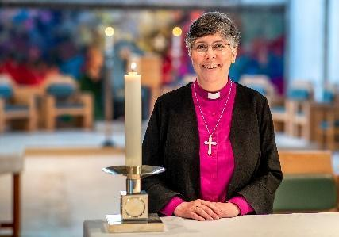
THE DIOCESE: A MESSAGE FROM BISHOP GULI
Covering Essex and East London, Chelmsford is one of the largest, most diverse dioceses in the Church of England. We are home to more than 3 million people representing many socio-economic, ethnic and faith groups and a fantastic variety of cultures and traditions.
We have enormous opportunities for mission and service and considerable challenges to face and resolve as we continue to deal with the local, national and global challenges that have a direct impact on our parish churches, schools, chaplaincies and the communities we serve.
It is within this context and following a period of listening and discernment that started when I became Bishop of Chelmsford in 2021, that we set out a future direction of travel as a Diocese with a focus on travelling well together:
- Our purpose is to love God and to love our neighbour; to worship faithfully and empowered by the Holy Spirit, witness to the love of God revealed in Jesus Christ as we serve the extraordinarily diverse array of local communities in Essex and East London.
- Our approach is to enable and empower parishes and worshipping communities to discern how they are to be God’s people in their own very different local contexts and as part of one diocesan family.
- Underpinning our approach is an invitation to a way of being articulated by shared diocesan values which might shape how we travel together, support each other and provide mutual accountability.
Since I became Bishop of Chelmsford, I have witnessed people’s great warmth and I have seen first-hand, the wonderful things going on in our parishes and schools. Any new priest joining us in the Diocese of Chelmsford does so at a time of challenge, a time of change and most significantly a time of hope for our Church in this most diverse and vibrant of dioceses.
+Guli
Bishop of Chelmsford

The Archdeaconry of Southend in the Bradwell Episcopal Area
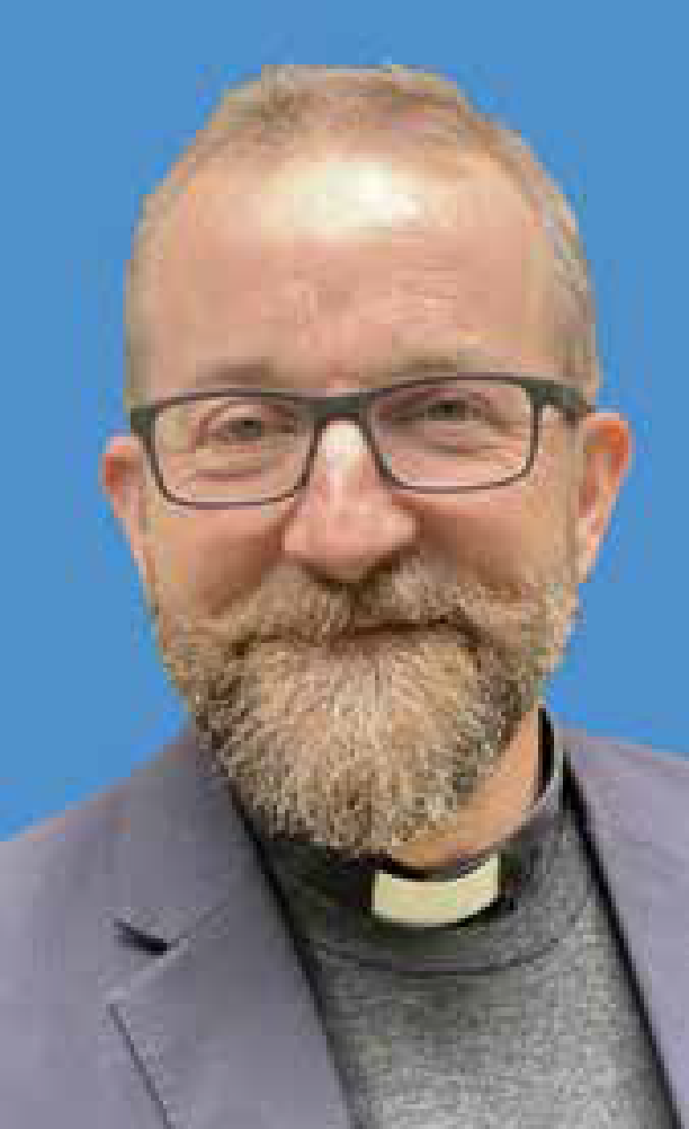

Dear friend,
This team has so much potential to bless Billericay and build God's Kingdom here. Not only that, I think there is a calling to reach further across the deanery in support of all sorts of other churches, linking arms with the many Christians doing good evangelism and social action work together. I pray that the new team Rector will lead everyone to look out as well as up.
The Bradwell Area is beautifully diverse, rich in culture and among our varied communities. The nine deaneries of the Episcopal Area cover south and mid Essex, from Epping Forest and Ongar, Brentwood and Thurrock on the M25 out to the coast with the River Thames as the southern border and the Blackwater in the north. Our two cities are Southend and Chelmsford. Significant new housing is being built across our area. We serve the 20th century suburban populations of Basildon and Hadleigh as well as a spread of rural situations including Rochford and Maldon & Dengie where St Cedd’s 7th century Bradwell Chapel still stands as the bridgehead of ‘mission to the East Saxons’.
My team and I, with each deanery, are trying to help one another bring about positive changes and establish ways of mutual support in each local context. Some of this counts as ‘innovation’, some is in sharing learning and ideas, some are expressing our being in ways we’ve been called to for generations. There is a changing culture in the Bradwell area with a focus on equipping each church with tools for renewal and the means to foster a sense of abundance. We welcome innovators and leaders of change who are led by the spirit. We welcome those who show and tell the good news of Jesus afresh among each generation and context. Most of all we welcome priests to apply for posts who are people of prayer, who call upon our loving Heavenly Father for the ways and means to display his love and win people into his Kingdom.
I would warmly welcome you to listen out for the prompting of God in respect of this post. Ask him in prayer to bless the people in the place you read about here. Ask for love to abound more and more in knowledge and depth of insight so that you may be able to discern what is best. I hope that what you will contribute towards, along with the saints of God in this place, is the development of a loving, caring and nurturing environment in which everyone can do their very best and have a good time doing it! That is, under God I humbly submit, what we are here for in support of you were you to join the team. Do be in touch with me or the Archdeacon if you want to know more detail on any of this.
With my blessings,
The Right Reverend Adam Atkinson, Bishop of Bradwell
A Word from the Venerable Dr Sue Lucas, the Archdeacon of Southend

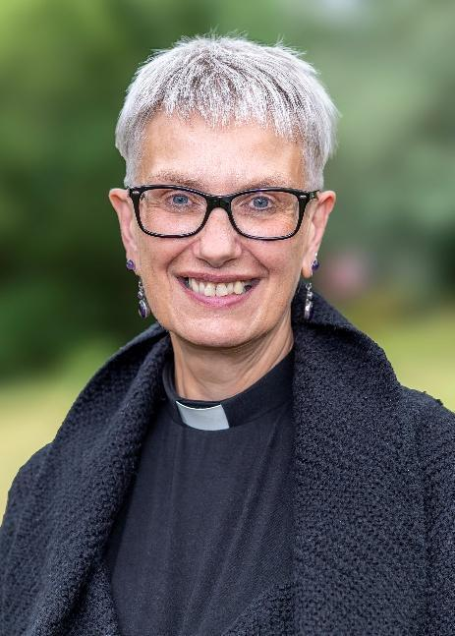
I am delighted you are discerning your call to this role in the archdeaconry of Southend. This archdeaconry has something for everyone – from the coastal city of Southend-on-Sea itself, to the mainly rural area around Rochford, to the industrial docks around Thurrock, right on the edge of London. It is an exciting place to be, and I am determined to both support and appropriately challenge the clergy here to be the best they can be for God’s people in this place. My prayer is that our parishes and people will see themselves as missional and ministering communities, led by confident and well-resourced clergy.
We are living through times of change, in the world and in the church. Here in the archdeaconry of Southend, within the Diocesan values of Travelling Well Together, (travelling-well-together-25-final-compressed.pdf) we seek to embrace change as coming from God: ‘to live is to change and to be perfect is to have changed often,’ wrote John Henry Newman. There are challenges and tensions of course within any period of significant change, but I believe that if we remain open to God and committed to one another, God is doing something new and exciting here.
My hope is that you feel called here because you are someone who also recognises the need for change, and who is curious and excited to lead God’s people through it here. I hope you are up for working collaboratively with clergy and lay leaders, and, yes, with your archdeacon and area dean, to help discern a sustainable and flexible shape for the life of the church in this place.

A Message from the Basildon Deanery
The Deanery covers the towns of Basildon, Billericay and Wickford and the rural areas surrounding them. Most of the population is in the three urban areas, Billericay (including Great Burstead and Ramsden Crays), Wickford north of the A127 and Basildon to the south. There are areas of high deprivation in Basildon and pockets of significant need elsewhere, notably in Great Burstead.
The total population is circa 175,000 and rising: significant regeneration is already under way in Basildon and new housing developments are being built or planned throughout the Deanery.
The council’s Corporate Plan 2022-2026 set out three key strategic themes which cover the full range of their responsibilities and priorities and to which we want to make our contribution:
• People: We want Basildon to be home to healthy and active local communities able to support themselves and each other.
• Place: We want Basildon to offer a high quality of life for all residents through attractive, liveable, accessible and safe neighbourhoods and towns along with the provision of enduring facilities, green spaces and town centres that meet the needs of the community.
• Prosperity: We want Basildon to have a thriving, dynamic and diverse economy where all our communities benefit from increased opportunity and our workforce has the right skills for our local economy and beyond.
We have developed a Deanery website to profile in a new way key aspects of each of our parishes and link these to other areas and places of interest in the borough.
Ecumenical links are strong in each of the urban centres and there is a tradition of collegiality within the deanery chapter. The Deanery Plan commits us to continuing to value difference of tradition, to discern how sometimes scarce resources can best be used, to work together in responding to new housing developments, and to encourage vocations to ordained ministry, and to both licensed and less formal lay ministry, including the ministry of administration. Having used mission consultants to identify ways to tackle barriers to mission, we now employ a Deanery Mission Support Administrator to assist in addressing the burdens of administration and have an initiative engaging young people in playing the organ.
The deanery vision includes a commitment to working more closely together and also commits us to equipping and growing ordained and lay ministry and engaging in mission – especially among children and young people. These strands remain strong in the life of each of our parishes.
Following reorganisation of several parishes, we have begun working together on the development of a new Deanery Plan. Joining our Deanery at this time will include the opportunity to contribute to and shape that plan.
Revd Jonathan Evens, Area Dean of Basildon
Christine Coe, Lay Chair

Parish Finance – Details of the parish finances can be found on the charities commission website - https://register-of-charities.charitycommission.gov.uk/en/charity-search

For an informal conversation contact:
Ven Dr Sue Lucas, Archdeacon of Southend,
a.southend@chelmsford.anglican.org

Or Christine Coe, Churchwarden
christine.coe@billericaychurches.org

Application Form from the Archdeacon of Southend’s Office ldolton@chelmsford.anglican.org

Closing date: 12 noon on 10th September 2026
Interviews: 20th October 2026

