The Parish of St Francis of Assisi
Barkingside

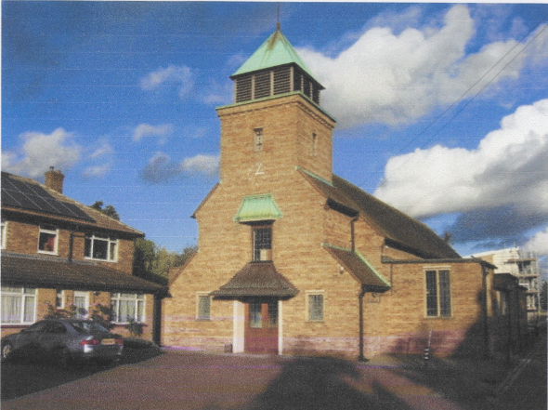

Parish Profile

Welcome

We are delighted to welcome you to this Profile for the Parish of St Francis of Assisi, Barkingside, Ilford.
We hope you find this document both helpful and encouraging, and that it offers a clear sense of who we are, where we are rooted, and where we hope to grow. Our aim is to give you a real insight into our life together, our vision for the future, and how your ministry might flourish among us.

We are a small but committed congregation, looking for leadership and a new vision to carry us into the next chapter of our church life. As a church we would like to grow in numbers and in influence in our
parish by looking outwards and building links with our local community.

Located in the northern part of the London Borough of Redbridge, the parish is a pleasant area in which
to live. It is largely residential, includes a new housing estate and comprises a diverse mix of different nationalities and faiths. The church and adjacent vicarage, in Fencepiece Road, are well connected to other parts of the Borough and beyond by three bus routes, and Hainault station (Central Line) is a 5 minutes walk away. There are good facilities nearby - Fairlop Waters Country Park and Claybury Park; a selection of supermarkets and local shops; Fullwell Cross Leisure Centre and library.

Thank you for your interest in St Francis of Assisi, Barkingside. We hope this Profile inspires you and helps you to imagine yourself as part of our journey. We look forward to the possibility of welcoming you among us.
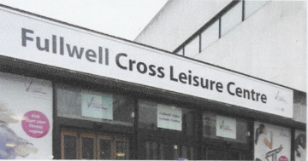
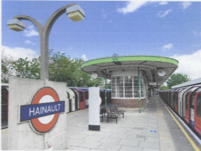
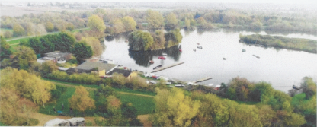
Hainault Station; Fullwell Cross Leisure Centre;

Fairlop Waters Country Park
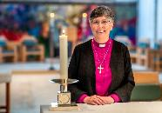
THE DIOCESE: A MESSAGE FROM BISHOP GULI

Covering Essex and East London, Chelmsford is one of the largest, most diverse dioceses in the Church of England. We are home to more than 3 million people representing many socio-economic, ethnic and faith groups and a fantastic variety of cultures and traditions.
We have enormous opportunities for mission and service and considerable challenges to face and resolve as we continue to deal with the local, national and global challenges that have a direct impact on our parish churches, schools, chaplaincies and the communities we serve.
It is within this context and following a period of listening and discernment that started when I became Bishop of Chelmsford in 2021, that we set out a future direction of travel as a Diocese with a focus on travelling well together:
- Our purpose is to love God and to love our neighbour; to worship faithfully and empowered by the Holy Spirit, witness to the love of God revealed in Jesus Christ as we serve the extraordinarily diverse array of local communities in Essex and East London.
- Our approach is to enable and empower parishes and worshipping communities to discern how they are to be God’s people in their own very different local contexts and as part of one diocesan family.
- Underpinning our approach is an invitation to a way of being articulated by shared diocesan values which might shape how we travel together, support each other and provide mutual accountability.
Since I became Bishop of Chelmsford, I have witnessed people’s great warmth and I have seen first-hand, the wonderful things going on in our parishes and schools. Any new priest joining us in the Diocese of Chelmsford does so at a time of challenge, a time of change and most significantly a time of hope for our Church in this most diverse and vibrant of dioceses.
+Guli
Bishop of Chelmsford


Find out more about our Diocesan Direction of Travel and Values:


A message from The Area Dean, Revd. James Gilder, Redbridge Deanery

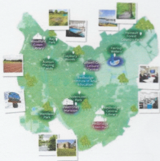
Redbridge Deanery contains all the parishes within the London Borough of Redbridge. It is one of five London boroughs which together form the Barking Episcopal Area of the Diocese of Chelmsford, and it sits within the West Ham Archdeaconry. London over the Border, as it is sometimes colloquially known, has its origins within the old county boundaries of Essex. However, nowadays much of Redbridge feels solidly part of London:
a hugely diverse area with excellent food options, a good transport network, and of-course, a vast range of people in various stages of wealth and poverty, often living not much more than a stone's throw away from each other.

Perhaps more surprisingly, Redbridge is quite a green borough, and protected space and parks can be found in almost every parish. The Central Line connects much of the borough which means that commuting into the City from Redbridge is relatively easy - whilst the M11 and A12 make getting out of London by car a fairly painless task. Cycling is also a popular option amongst several of the clergy in the deanery! The Borough boasts a range of good schools, both at primary and secondary level, along with opportunities for involvement in numerous clubs and activities. Music, drama and sport all abound here. Sadly, there also exists in Redbridge all the challenges of crime and social deprivation that one might expect from anywhere which seeks to pack 300,000 people into just a few square miles.

Our deanery is an active one, with 23 churches, the majority retaining their own incumbent, along with lay leaders and self-supporting ministers. Our youngest ordained member of Chapter is in their twenties and our oldest, in their nineties. Redbridge Deanery encompasses most traditions of the Church of England, and our churches have a
good record of working together and supporting each other despite our occasional differences. The deanery also has a good rate of parish share payment and it is one of the largest annual contributors to Chelmsford Diocese’s share collection.

We have Chapter meetings four times a year, plus a social event in the summer, whilst Deanery Synod meets three times a year. All clergy are encouraged to take an active role in the deanery. Smaller, informal groupings of clergy or parishes, exist to offer each other mutual assistance and new incumbents can be assured of a warm welcome from their colleagues, as well as support should they need it.

Statistics suggest Redbridge to be a religious borough. It is true that people here are used to seeing those of faith, albeit from a range of faiths, openly displaying their devotion to God. Faith is taken seriously here and although the Church of England may not be the majority religion in much of the borough, opportunities abound for the work of God to prosper.
I hope you will consider applying for this post within our deanery. Please do not hesitate to contact me, should you have any questions whatsoever.
Yours,
Revd James Gilder, Area Dean of Redbridge
jbgilder@hotmail.com

The Church

St Francis of Assisi Church originates from a Maypole Mission iron church built in 1890 at Fulwell Hatch. A Conventional District was formed in 1935, and a temporary church was built. The present church on Fencepiece Road, is a traditional brown brick church designed by JJ. Crowe, opened in 1956. It is built in a traditional church style with an aisled nave, chancel, Lady Chapel and west tower.

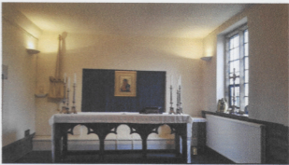
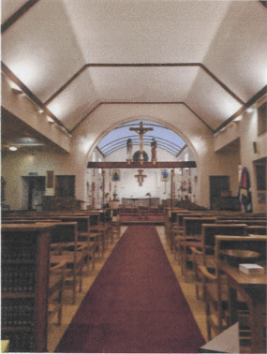
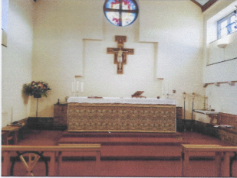

Our Worship

Worship at St Francis has always been in the Catholic tradition, with the eucharist central. Vestments are worn, and at sung Masses there are altar servers, and incense is used. The ministry of female and male priests is welcome. The liturgy follows Common Worship. Festivals and Holy Days are observed. There is a regular organist for the Parish Mass. Congregational settings are used, and a cantor supports the singing.

Sunday worship
8am Mass (average attendance 9 at the October 2025 count)
10.15am Parish Mass (average attendance 24 at the October 2025 count)

Weekday worship
Thursday 10am Mass
The congregation is largely elderly. There is no Sunday School, and almost no children or teenagers attending worship.
Our New Priest

We are looking for a [the Archdeacon will need to give us the exact title of the post]

The parish has reached a challenging point in its life, and we feel we need a priest who will bring experience of parochial ministry, will be a leader in the church and community, and can inspire a fresh vision and sense of mission for St Francis. There is an appreciation by the PCC that there will need to be change if St Francis is to grow.

Ideally, we are looking for a man or woman priest who can meet some of the items on our ideal wish list’:

- Visit parishioners and others in the parish
• Build relationships with local schools and other community organisations
• Teach and help people grow and develop in their Christian journey
- Encourage families and children into St Francis
• Build the confidence of the congregation; develop and use the gifts those within St Francis
- Review the financial situation of St Francis to put the church on a more sustainable path
- Improve links between St Francis and other churches in north Ilford, and in Redbridge Deanery
- Encourage and grow church social events and activities

The Vicarage
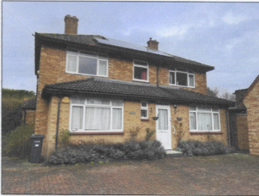
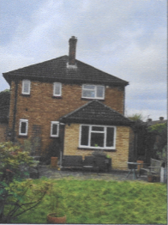
The Vicarage is adjacent to the church, in Fencepiece Road, IG6 2LA. The house has double glazing and gas central heating. Downstairs consists of two reception rooms, a study, utility room, toilet and kitchen. Upstairs there are 4 bedrooms, a bathroom with a toilet and shower and storage cupboards. There is a manageable sized garden.

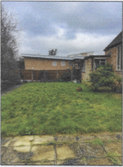
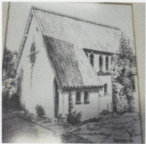
The Parish Hall

The Parish Hall is situated on land behind the church, on the site that the original St Francis of Assisi Church (pictured right) was built. It was built and opened in 2007, at the same time that the current church building was refurbished due to a fire which engulfed and destroyed the inside of the church.

Hall facilities
- A purposely built large kitchen
- 8 or 9 car parking spaces located at the front of the hall
- An office
- Separate male and female toilet facilities for hall users
- Chairs and tables for use by hall users
- CCTV cameras around and inside the hall which can only be viewed and accessed via the church building

The Davison Hall (in memory of Joan Davison)
This is divided into two sections - a large room and a small room, which are divided by sliding wooden panels. These two rooms are currently used by Little Acorns Preschool & Nursery Monday to Friday during the school term-time only.

The Wheatley Room
A smaller room located on the far end of the hall. This room is currently furnished with chairs and a table so can be used by small group for meetings, quizzes, games etc.

The Parish Hall is seen as a major asset of the church and a means by which the income of the church can be increased. It is recognised that for this to be realised a hall manager needs to be appointed to oversee the hiring, cleaning and general management of the building:
North Ilford Fellowship of Churches

The North Ilford Fellowship of Churches, (NIFOC), is an ecumenical association of over a dozen Churches founded in 1978 by a group of local ministers. The object is to foster good relationships within the Christian Community in North Ilford and to be a public witness to our neighbours. The cross is erected on the roundabout at the end of the High Street during Advent and Holy Week by participating churches reminds passers-by that faith in our God underpins life.

During the year various events and combined services are held. During Advent the posada (a traditional Mexican nativity scene of wooden figurines) is displayed at different shops in Barkingside. It resides at various churches each Sunday during the season. Just before Christmas we arrange carol singing at the two pubs/restaurants in the High Street. During January we hold a service to mark the Week of Prayer for Christian Unity. We also hold services to mark the World Day of Prayer and Pentecost. Throughout Lent the various churches hold austerity lunches (soup and a roll) to raise funds for Christian Aid, and on Good Friday members of our congregations come together in a walk of witness from the Law Courts in Barkingside to Ken Ashton Square by the library where we hold a public
service of praise and worship honouring our Saviour's sacrifice on our behalf and distribute tracts.

Church Activities
Our current activities and social events:
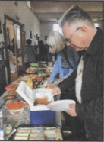
- Baking with Brass - an annual afternoon of music played by the Fairlop Brass Band, with refreshments
- Bring and Share lunch
- Congregational lunch
- Community Christmas Carol Service with Fairlop Brass Band
- Annual summer Cream Tea Afternoon in the Vicarage garden
- Tea and coffee after the Sunday Parish Mass
- Bible Study Group, online, once a fortnight
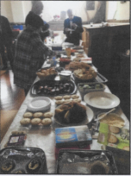
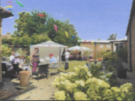
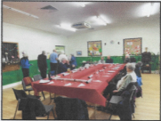
- On-going collection of food items for Redbridge Food Bank.

