St John North Woolwich w Silvertown Church Profile:

The Parish, The Church, Community Centre and Its Environs at present:

St John’s Parish Church of North Woolwich with Silvertown, located on Albert Road, London E16 2JB. The church stands between London City Airport and the River Thames, with the Woolwich Ferry and Tate & Lyle factory only a short walk away.
The parish is an area of contrasts, with established working-class communities, newer riverside developments, and a growing mix of cultures and ethnicities. While regeneration has brought new opportunities, parts of North Woolwich still experience significant social need, particularly among young people and families.

(The area map is available at Google Maps on London E16 2JB)

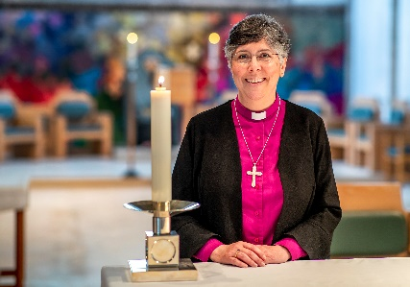
THE DIOCESE: A MESSAGE FROM BISHOP GULI

Covering Essex and East London, Chelmsford is one of the largest, most diverse dioceses in the Church of England. We are home to more than 3 million people representing many socio-economic, ethnic and faith groups and a fantastic variety of cultures and traditions.
We have enormous opportunities for mission and service and considerable challenges to face and resolve as we continue to deal with the local, national and global challenges that have a direct impact on our parish churches, schools, chaplaincies and the communities we serve.
It is within this context and following a period of listening and discernment that started when I became Bishop of Chelmsford in 2021, that we set out a future direction of travel as a Diocese with a focus on travelling well together:
- Our purpose is to love God and to love our neighbour; to worship faithfully and empowered by the Holy Spirit, witness to the love of God revealed in Jesus Christ as we serve the extraordinarily diverse array of local communities in Essex and East London.
- Our approach is to enable and empower parishes and worshipping communities to discern how they are to be God’s people in their own very different local contexts and as part of one diocesan family.
- Underpinning our approach is an invitation to a way of being articulated by shared diocesan values which might shape how we travel together, support each other and provide mutual accountability.
Since I became Bishop of Chelmsford, I have witnessed people’s great warmth and I have seen first-hand, the wonderful things going on in our parishes and schools. Any new priest joining us in the Diocese of Chelmsford does so at a time of challenge, a time of change and most significantly a time of hope for our Church in this most diverse and vibrant of dioceses.
+Guli
Bishop of Chelmsford


Find out more about our Diocesan Direction of Travel and Values:

www.chelmsford.anglican.org/travelling-well-together

Newham Deanery
Part of the Archdeaconry of West Ham in the Episcopal Area of Barking
Where the world meets.
Newham Deanery is conterminous with the London Borough of Newham, home of the 2012 London Olympics and home to over 350,000 residents (Census 2021).
We are so large that if we were elsewhere, we would be an Archdeaconry or even a Diocese. We have 24 churches, including two recent plants with no building. Our growth has come through our diversity, not just in styles of worship, but in the nationalities that find a home in an Anglican Church. Newham is where the world meets, and we have stipendiary vicars from at least ten countries, including Bulgaria, Myanmar, Brazil and Jamaica. In the last year, our church plants have added over 250 new members.
We have a strong chapter, and our Deanery has recently undertaken a wide-ranging listening exercise to understand more fully how God has been at work and how churches can support each other going forward. There is a very strong lay presence within the Deanery, ably led by our Lay Chair and Assistant Lay Chair. We are keen to ensure the gifts of the whole Church are explored and built up for the Kingdom of God.
If you come to Newham, expect God to do things to you and through you. We are not the last stop before retirement; we are mission-oriented and alive!
Rev Amy Stott,
Area Dean.

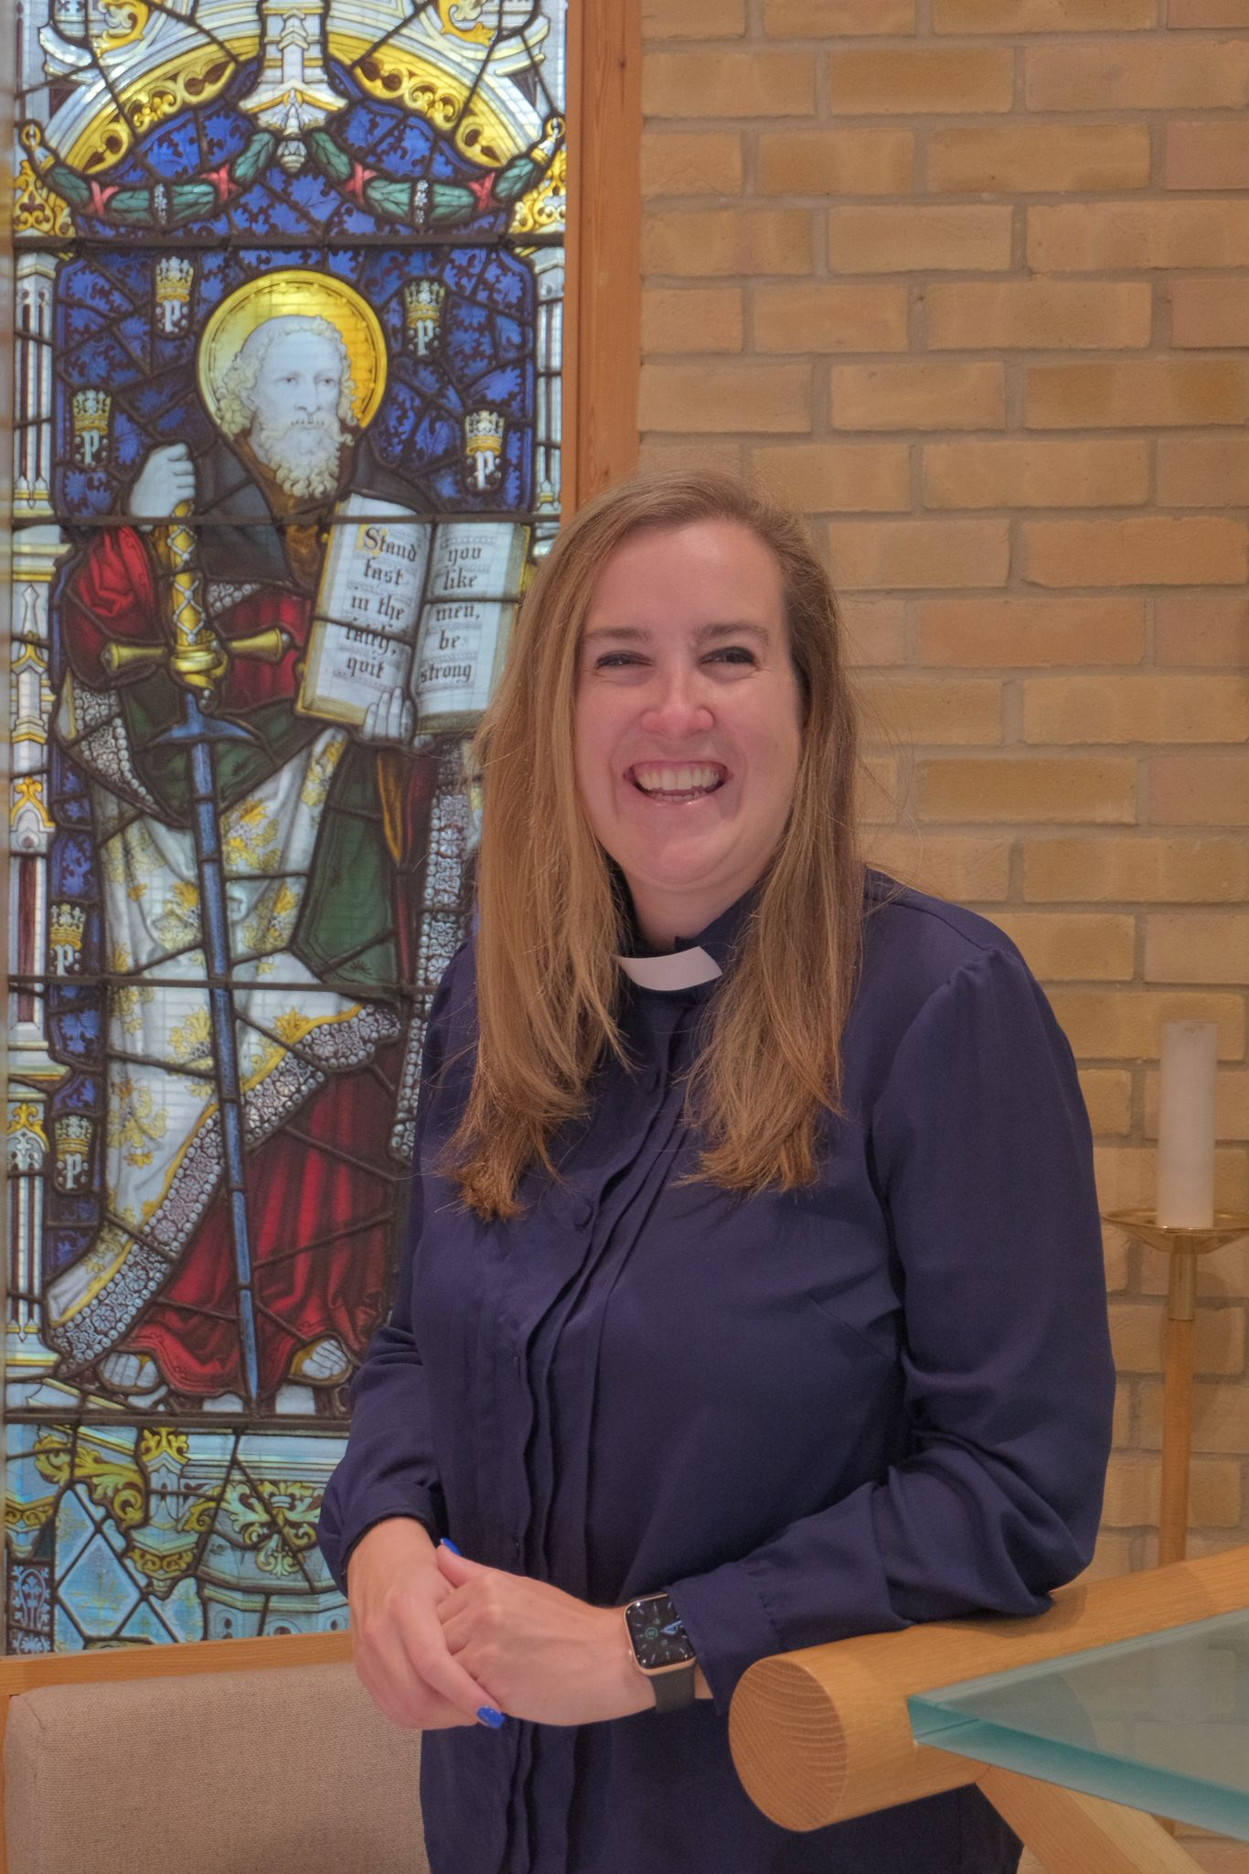

St John’s Family & its Activities:

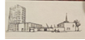

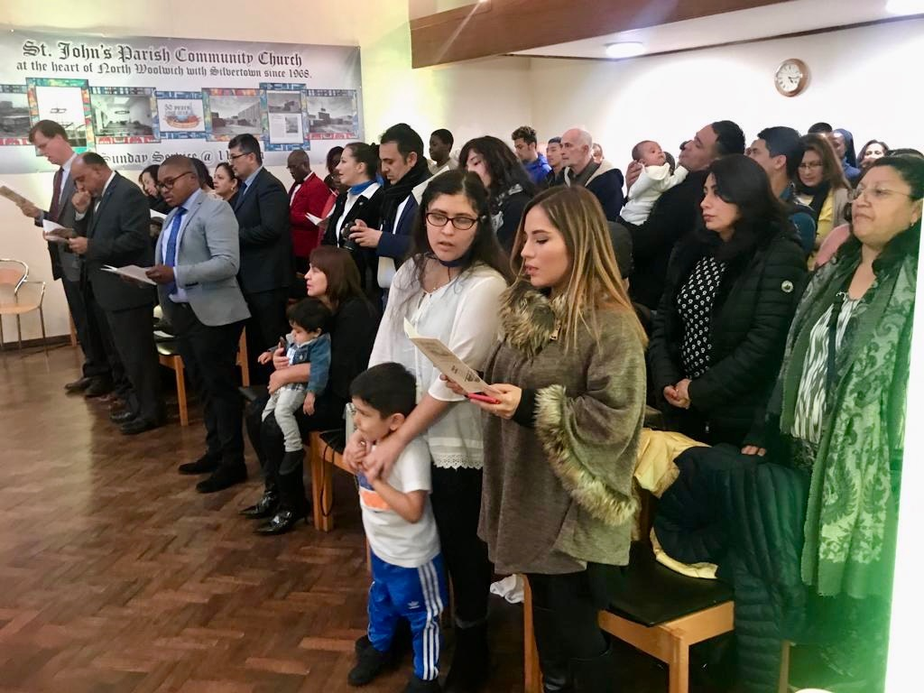
St John’s Church is an established yet evolving Church of England (Anglican) parish, welcoming a regular congregation of approximately 25–45 adults and 12–15 children each Sunday. The congregation is a vibrant and diverse community, predominantly of British, African, and Caribbean heritage.

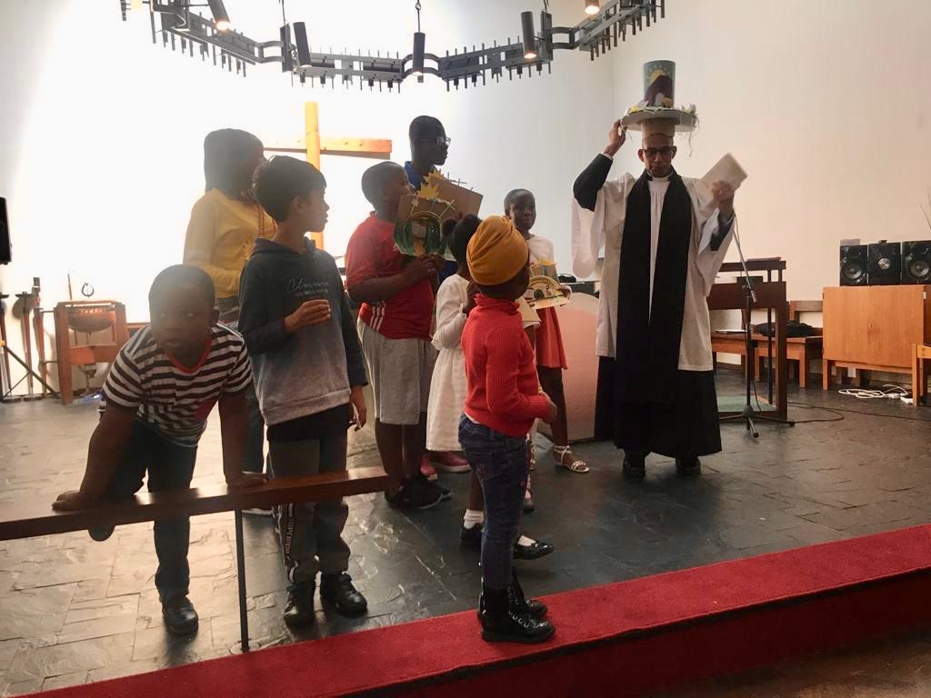
Children and Youth: St John’s offers a Sunday School and a Saturday Club, providing engaging Bible teaching, fellowship, and activities designed to nurture the faith and spiritual growth of children and young people.

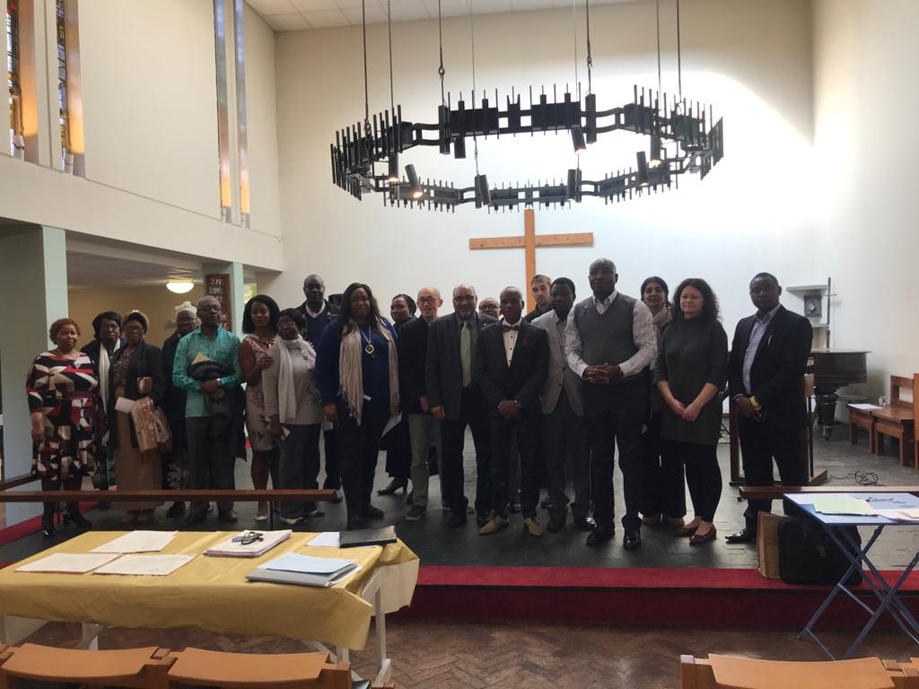
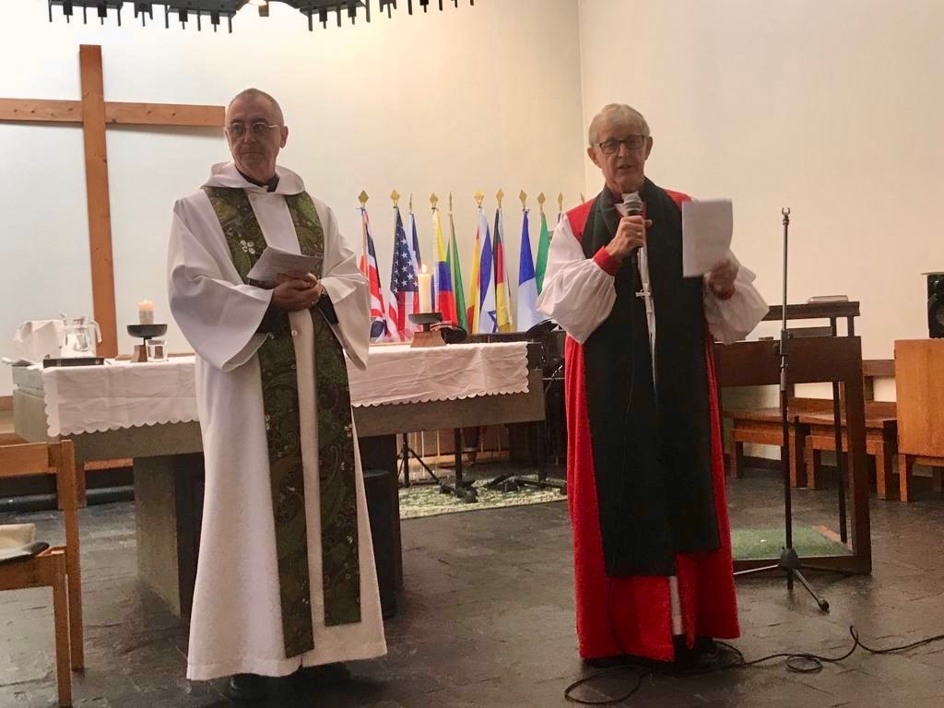
embers of the congregation take an active part in the Sunday Parish Communion Service, contributing through Scripture readings, musical performances, and leading intercessions, reflecting the inclusive and participatory life of the church.

Pastoral Care and Fellowship
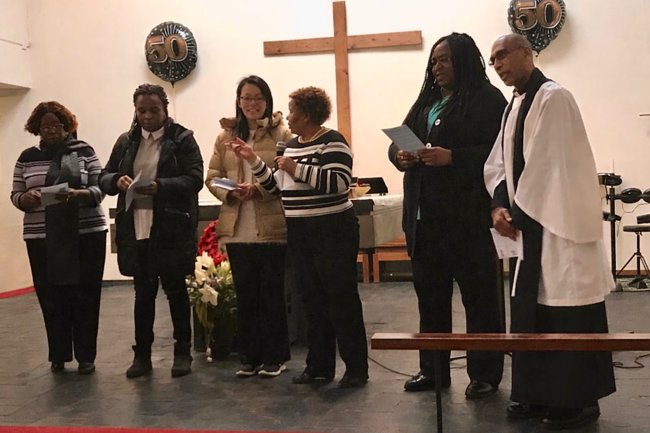
St John’s has an active Pastoral Care and Visiting Team led by the priest, supported by a welcoming committee that ensures all who attend services feel included and valued. The Mothers of the Church play a vital role in offering care and support to families, particularly those new to the community or in need of practical or spiritual assistance.

Music and Worship
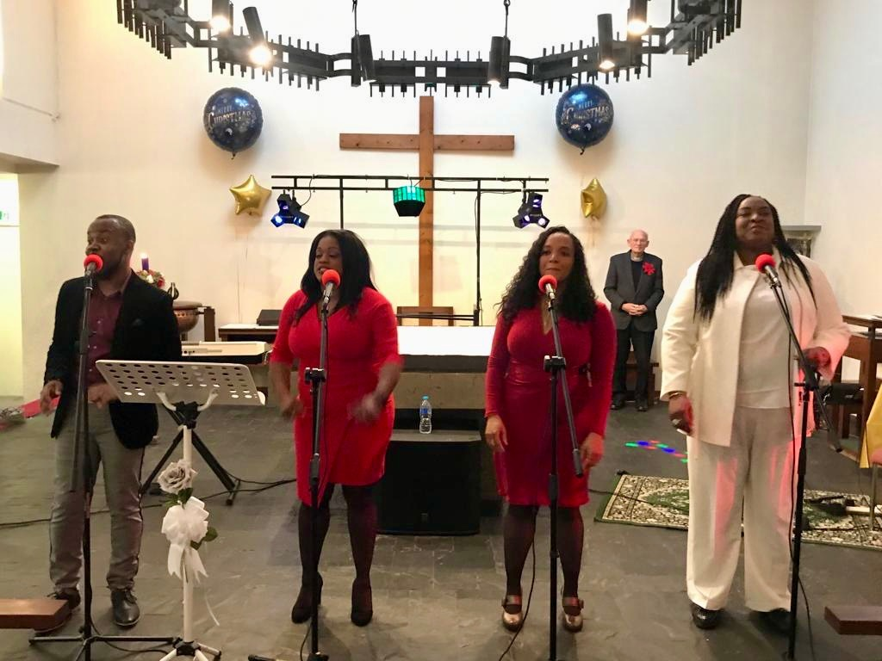
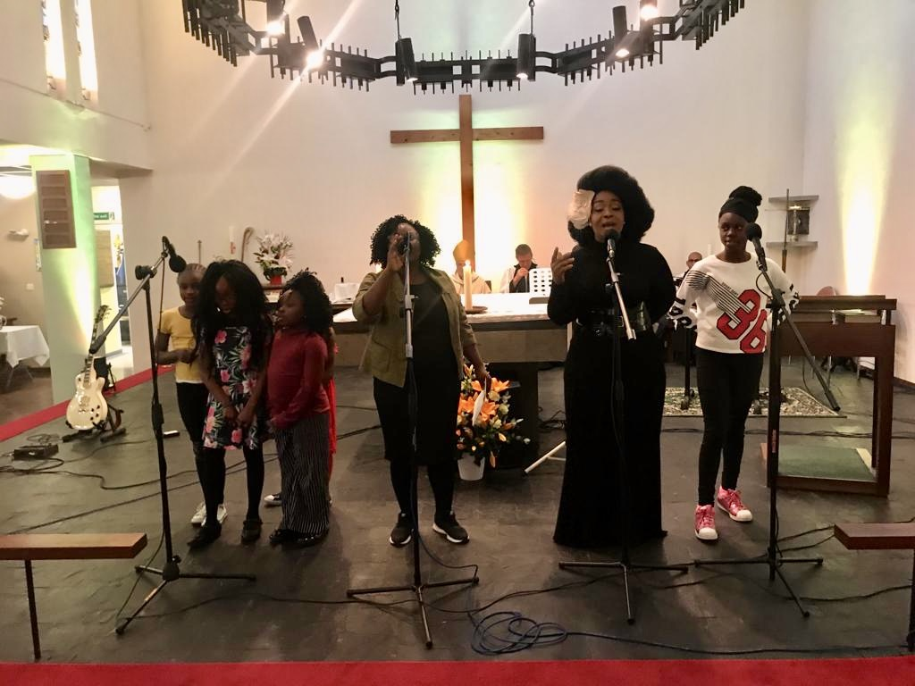
The church is blessed with a beautiful Pipe Organ and a Grand Piano, both awaiting enthusiastic and skilled players. In the absence of a live music group, St John’s employs an internet-linked music system that provides congregational hymns during worship. Time is also set aside within the service structure for musical contributions and renditions from members of the congregation.

Bible Study and Prayer
Members and friends of St John’s are warmly invited to join the weekly online Bible Study and Prayer Meeting, held every Thursday evening from 7:00 to 8:00 p.m. The session includes Scripture study, prayer, and songs of worship. The meeting link is shared via the church’s WhatsApp group.

The Church Building
The church building, consecrated on 28 October 1968, has undergone regular maintenance in accordance with a scheduled plan guided by the Quinquennial Inspections. The most recent inspection, conducted in 2023, identified the need for roof repairs, electrical upgrades, and modernisation of the heating system.

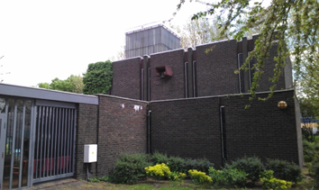
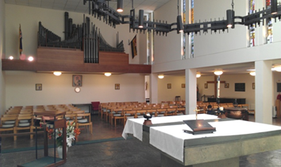
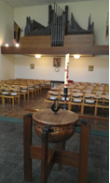
The Baptismal font & the Organ
- The church provides adequate access for people with disabilities; however, wheelchair access to the toilet will need improvement in future upgrades, alongside planned heating system modernisation.





- Inside the church, the atmosphere is quiet and serene, fostering reflection, worship, and prayer. Artwork and paintings, generously contributed by a member of the congregation, enhance the church’s aesthetic appeal, both at the entrance and within the main worship space.

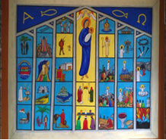

- Although the Sanctuary, with its Communion Table, occupies nearly one-third of the main worship area, it currently does not restrict space for the congregation. However, as the congregation grows, the Sanctuary may need to be reconfigured to allow additional seating and create more room for worshippers.

Church Garden
The church garden, located in the courtyard between the church and the church centre, serves as a space for fellowship, quiet reflection, and seasonal activities such as barbecues in the summer. A remembrance section, marked with memorials for those who have passed, adds a contemplative element to the garden. Summer gatherings in the garden have attracted many new visitors, and the church continues to explore ways to enhance its use for the benefit of both members and the wider community.
Shared Use of the Church Building
While the church building was previously shared with the Roman Catholic community, it is now used on Friday evenings only by The Redeemed Christian Church, reflecting the church’s ongoing engagement with the local faith community.
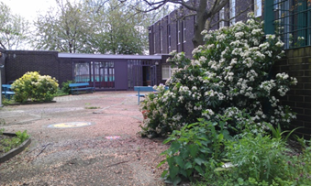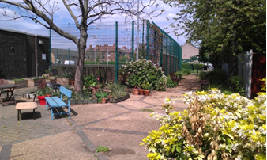

The Vicarage
The vicarage, built at the same time as the church, is a pleasant, detached house featuring a garden and garage. It is conveniently situated adjacent to the church, providing easy access for the clergy.

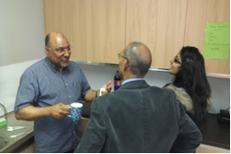

Fellowship after Service
Our after-service tea and coffee time provides a warm and welcoming opportunity for congregation members to connect, build friendships, and foster encouraging Christian fellowship.

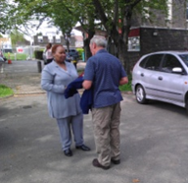

Local Ecumenical Partnership:
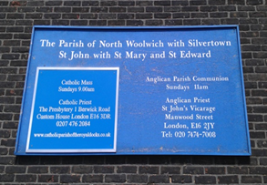

The Redeemed Christian Church of God (RCCG)
The RCCG holds worship services at St John’s on Friday evenings and Saturday mornings. St John’s continues to maintain a positive and cooperative relationship with both churches, fostering a spirit of mutual respect and collaboration.

The Parochial Church Council (P.C.C.)
Our PCC consists of fourteen members, including two churchwardens, a secretary, a treasurer, and a Deanery Synod representative. Meetings are held six times a year, typically on Sundays immediately following the service at the church.
The Church Car Park
We are fortunate to have a car park at the front of the church, accommodating approximately 12–15 cars. The area is surrounded by trees, creating a welcoming and friendly atmosphere for all who visit.

Finance & Accounts
St John’s maintains a current account and a business reserve account with National Westminster Bank, as well as CBF deposit funds with the Diocese. The church accounts are overseen by the Deanery Finance Office. St John’s has consistently paid its Diocesan quota in full via monthly direct debit.
An envelope scheme is in operation, and where applicable, covenants and Gift Aid are applied, with claims made in accordance with these contributions. Each year, 10% of direct giving is allocated to selected charities, as agreed by the PCC.
The church holds a lease with the activity centre (RDLAC) at a very low rental rate. The PCC would welcome the minister’s assistance, in consultation with the Diocesan Financial Board, to renegotiate the lease to reflect current market rent, which would enable an increase in the parish share.

St John’s Community Centre
The Community Centre, previously operated by the Royal Dock Learning Centre (RDLAC), returned to the management of the PCC and the Diocese of Chelmsford in October 2024. St John’s continues to operate most of the former community programmes, including:
- Community Food Bank
- Painting and artwork for seniors
- Coffee mornings for drop-ins
- Men’s health and wellness forum
- Line dancing for seniors
- Yoga group
- Bowls group for seniors
- Stroke recovery therapy group
- Hot meal services
- Corporate volunteer participation

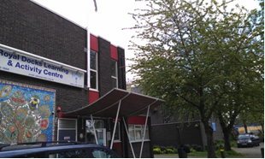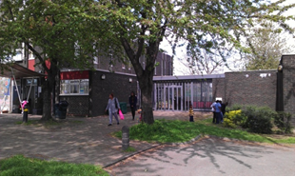

A Growing Partnership with the Community Centre
A fresh understanding and relationship is being cultivated between the church and the Community Centre. Steps are being taken to foster a shared vision for working together, enhancing community engagement, and advancing the church’s role in the rapidly growing areas of North Woolwich and Silvertown.

Towards the Future
The churchwardens have taken great responsibility in guiding the life of the church, offering dedication and pastoral care. Other team members have shown initiative in leading and sharing the Word of God.
St John’s aspires to remain a family-focused church, welcoming and encouraging youth and children. To support this vision, the church is introducing:
- A simple invitation leaflet
- A regular Sunday service leaflet with Bible readings
- Further development of the church website
The Standing Committee, comprising the churchwardens, treasurer, PCC secretary, and the parish priest, meets to address the immediate needs of the church.
The congregation seeks to grow in faith and numbers, with a target increase from approximately 25 adults to 40–50 and from 10 children to 12–20. Emphasis is placed on welcoming newcomers and integrating them into the church family.

Training and Lay Ministry
Several members of the PCC and congregation have undertaken formal training:
- Course in Christian Studies (CCS): 2 PCC members completed
- Time to Share evangelism course: 4 members completed
- Diocese Lay Ministry programme: 2 individuals successfully completed and are actively involved in church work
The church hopes to appoint a full-time minister who is approachable, pastorally minded, and passionate about evangelism. A minister with musical gifts would be particularly welcomed.

Achievements
St John’s has made significant progress in ministry, fellowship, and community engagement:
- Established worship with music support
- Set up regular Sunday Club and Bible Study & Prayer Group
- Introduced Coffee Mornings and Prayer Breakfasts (1st Saturday of each month)
- Founded St John’s Mothers’ Union
- Built links with Royal British Legion, Tate & Lyle, Drew Primary School, and Oasis Academy
- Hosted community group meetings, including the Community Food Enterprise
- Maintained partnerships with Roman Catholic Church and RCCG
- Organized summer get-togethers and United Christmas Carol Events
- Recommended members for preaching, theological studies, and evangelism courses
- Supported youth participation through Youth Alpha
- Developed partnerships with Church of Ascension and St Mark’s, Beckton
- Introduced regular Sunday service leaflets
- Hosted Chapter & Deanery Synod meetings
- Carried out necessary repairs and maintenance in line with Quinquennial inspections

Looking Forward
St John’s continues to seek fresh ways to connect with the community, share the Gospel, and make the church a welcoming presence in the parish. Key goals include:
- Building relationships with local residents and groups
- Engaging young people, fostering spiritual growth, and sharing God’s Word
- Exploring ‘fresh expressions’ of church to reach new audiences and expand ministry

St John’s Vision
- To grow in Christian faith through the Word of God, Worship, and Sacraments.
- To make Jesus known within our community.
- To be witnesses to God by living lives guided by the Holy Spirit.

The History That Cannot Be Forgotten
St John’s Church has long played a vital role in the community, bringing people together and offering support and comfort to many. Originally opened in 1872 on Elizabeth Street as the Parish Church of North Woolwich, it was tragically destroyed by bombs and fire on the first day of the Blitz, 7 September 1940.

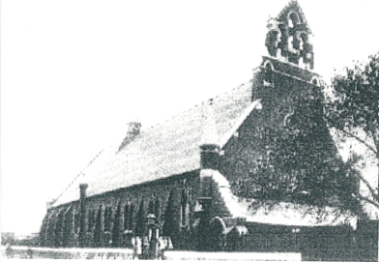
THE PICTURE OF THE OLD CHURCH

The Area
The parish of St John’s is located in a rapidly developing area of North Woolwich and Silvertown. The local landscape reflects a contrast between older housing and new private housing developments, including Barrier Point, Galleons in West Silvertown, and Britannia Village. Local transport has seen significant improvements, with the nearest railway station at George V (DLR) and regular bus services connecting Stratford, Manor Park, and Canning Town.

The Local Community
The parish serves a diverse and multicultural population, encompassing significant local institutions such as London City Airport, Tate & Lyle Refinery, and BT Satellite Station. There are currently two primary schools within the parish, with a third under construction. Nearby, the Docklands Campus of the University of East London and the Excel Centre lie at the parish boundary, providing additional educational and community resources.
Historically, North Woolwich and Silvertown were relatively isolated communities with limited educational and employment opportunities. The opening of the DLR transformed the area, attracting new residents and stimulating housing development. However, parts of North Woolwich continue to experience lower levels of welfare compared to the newer developments, with limited youth facilities and a recognized issue of young people congregating on the streets.
Before 2001, the community was predominantly white and either Christian or non-religious. Since then, there has been a significant influx of immigrants from Africa and Eastern Europe, contributing to the area’s rich cultural and ethnic diversity. From 2012 onwards, the Royal Docks area has undergone substantial regeneration, shaping a dynamic and evolving parish community.

Person Profile / The Vicar
St John’s Parish Church seeks a vicar whose background and experience will enable them to lead the congregation in partnership with the PCC while engaging the local community, particularly young people, children, and families.
We desire an incumbent whose approach to worship is flexible yet firmly rooted in the Word of God and the Liturgy of the Church of England. We recognise that serving as vicar of St John’s presents both opportunity and challenge, and we are looking for someone who is innovative, practical, and committed to developing the church’s involvement in this expanding and diverse area.
Key Characteristics
The vicar we seek will be:
- Friendly, compassionate, down-to-earth, open-minded, and wise, with a strong willingness to relate to and serve the community.
- A team player, working collaboratively with the PCC and ministry team.
- An effective leader with determination and understanding, able to unite and support the community.
- Ecumenically minded, valuing partnerships with other churches and faith groups.
- A leader who can help the church family grow in Christian faith through building relationships, mission, evangelism, and preaching the Word of God effectively.

St John’s Church
North Woolwich & Silvertown, Albert Road, London, E16 2JB
Note: This profile is acknowledged by St John’s PCC. No changes to its content are permitted without PCC approval.

